CYBERRISK GUIDEWIRE CONNECTOR

21CSP302L- PROJECT

Submitted by

PRABHANCHANA R[RA2411003010159]
RISHIKA YADAV [RA2411003010162]
SRINJOYEE ACCHARYA[RA2411003010450]

Under the Guidance of

(Dr. G. K. SANDHIA)

(Associate Professor, CTECH)

in partial fulfillment of the requirements for the degree of

BACHELOR OF TECHNOLOGY

in

COMPUTER SCIENCE ENGINEERING


DEPARTMENT OF COMPUTATIONAL INTELLIGENCE COLLEGE OF ENGINEERING AND TECHNOLOGY
SRM INSTITUTE OF SCIENCE AND TECHNOLOGY

KATTANKULATHUR- 603 203

MAY 2026


Department of Computational Intelligence

SRM Institute of Science & Technology

Own Work Declaration Form

Degree/ Course : B.Tech

Student Name : Prabhanchana R, Rishika Yadav, Srinjoyee Accharya

Registration Number : RA2411003010159, RA2411003010162, RA2411003010450

Title of Work : Cyberrisk Guidewire Connector
We hereby certify that this assessment compiles with the University’s Rules and Regulations relating to Academic misconduct and plagiarism, as listed in the University Website, Regulations, and the Education Committee guidelines.

We confirm that all the work contained in this assessment is our own except where indicated, and that we have met the following conditions:

- Clearly referenced / listed all sources as appropriate
- Referenced and put in inverted commas all quoted text (from books, web, etc)
- Given the sources of all pictures, data etc. that are not my own
- Not made any use of the report(s) or essay(s) of any other student(s) either past or present
- Acknowledged in appropriate places any help that I have received from others (e.g. fellow students, technicians, statisticians, external sources)
- Compiled with any other plagiarism criteria specified in the Course handbook / University website
I understand that any false claim for this work will be penalized in accordance with the University policies and regulations.

DECLARATION:
I am aware of and understand the University’s policy on Academic misconduct and plagiarism and I certify that this assessment is my / our own work, except where indicated by referring, and that I have followed the good academic practices noted above.

<<Student 1 Name &Sign>> <<Student 2 Name &Sign>> <<Student 3 Name &Sign>>
If you are working in a group, please write your registration numbers and sign with the date for every student in your group.

SRM INSTITUTE OF SCIENCE AND TECHNOLOGY KATTANKULATHUR – 603 203

BONAFIDE CERTIFICATE

Certified that 21CSP302L - Project report titled “CYBERRISK GUIDEWIRE CONNECTOR” is the bonafide work of “PRABHANCHANA R [RA2411003010159], RISHIKA YADAV [RA2411003010162], SRINJOYEE ACCHARYA [RA2411003010450]” who carried out the project work under my supervision. Certified further, that to the best of my knowledge the work reported herein does not form any other project report or dissertation on the basis of which a degree or award was conferred on an earlier occasion on this or any other candidate.

SIGNATURE  Dr. G. K. SANDHIA  SUPERVISOR  Professor  DEPARTMENT OF  COMPUTATIONAL INTELLIGENCE |  | SIGNATURE  DR. R. ANNIE UTHRA  PROFESSOR &HEAD  DEPARTMENT OF  COMPUTATIONAL INTELLIGENCE

EXAMINER 1 EXAMINER 2
Name & Signature Name & Signature

ACKNOWLEDGEMENTS

We express our humble gratitude to Dr. C. Muthamizhchelvan, Vice-Chancellor, SRM Institute of Science and Technology, for the facilities extended for the project work and his continued support.

We extend our sincere thanks to Dr. Leenus Jesu Martin M, Dean-CET, SRM Institute of Science and Technology, for his invaluable support.

We wish to thank Dr. Revathi Venkataraman, Professor and Chairperson, School of Computing, SRM Institute of Science and Technology, for her support throughout the project work.

We encompass our sincere thanks to, Dr. M. Pushpalatha, Professor and Associate Chairperson - CS, School of Computing and Dr.C. Lakshmi, Professor and Associate Chairperson -AI, School of Computing, SRM Institute of Science and Technology, for their invaluable support.

We are incredibly grateful to our Head of the Department, Dr. Niranjana G , Associate Professor & Department of Computing Technologies, SRM Institute of Science and Technology, for her suggestions and encouragement at all the stages of the project work.

We want to convey our thanks to our Project Coordinators, Panel Head, and Panel Members Department of Computational Intelligence, SRM Institute of Science and Technology, for their inputs during the project reviews and support.

We register our immeasurable thanks to our Faculty Advisor, Dr. Sivakumar S and Dr. Pavithra S, Department of Computing Technologies, SRM Institute of Science and Technology, for leading and helping us to complete our course.

Our inexpressible respect and thanks to our guide, Dr. G. K. Sandhia, Department of Computing Technologies, SRM Institute of Science and Technology, for providing us with an opportunity to pursue our project under her mentorship. She provided us with the freedom and support to explore the research topics of our interest. Her passion for solving problems and making a difference in the world has always been inspiring.

We sincerely thank all the staff members of Department of Computing Technologies, School of Computing, S.R.M Institute of Science and Technology, for their help during our project. Finally, we would like to thank our parents, family members, and friends for their unconditional love, constant support and encouragement

Authors

ABSTRACT
CyberRisk-Guidewire-Connector (CRGC) is a cybersecurity risk analytics and insurance review decision-support prototype designed to help users explore public vulnerability information and understand its potential relevance to organisational security. The system uses vulnerability intelligence from the National Vulnerability Database (NVD) and the Cybersecurity and Infrastructure Security Agency’s Known Exploited Vulnerabilities (CISA KEV) catalogue.
The project implements a web-based dashboard using React, TypeScript, Vite and Tailwind CSS, supported by a Python FastAPI backend, SQLAlchemy ORM and an SQLite database. The dashboard provides vulnerability exploration and filtering, ingestion history, organisation and asset management, and observed vulnerability findings. These features help organise public vulnerability records and asset-related information for review while distinguishing general vulnerability intelligence from findings associated with specific assets.
The project also includes a separate deterministic risk demonstration that evaluates three predefined cybersecurity scenarios. The model uses a base risk score and configured penalties for weak multi-factor authentication (MFA), exposed Remote Desktop Protocol (RDP), overdue critical vulnerabilities and low Endpoint Detection and Response (EDR) coverage. The healthy and remediated scenarios produce a score of 5/100, while the deteriorating security scenario produces a score of 80/100. These results illustrate how changes in security conditions affect a rule-based score.
CRGC operates as a local prototype, and its Guidewire-related insurance workflow is simulated rather than connected to a live Guidewire PolicyCenter environment. The risk scores are illustrative and have not been validated as actuarial measurements. The project demonstrates a structured approach to vulnerability intelligence exploration, asset-context review and explainable risk assessment, while identifying opportunities for future improvements in integration, validation, testing and security.
Keywords: Cybersecurity, Vulnerability Prioritisation, CVE, CVSS, NVD, CISA KEV, Risk Assessment, Guidewire, Insurance Decision Support.

TABLE OF CONTENTS
ABSTRACT v

TABLE OF CONTENTS vi

LIST OF FIGURES vii

LIST OF TABLES viii

ABBREVIATIONS ix

CHAPTER TITLE PAGE
NO. NO.

1 INTRODUCTION 1
  - Introduction to Project 1
  - Problem Statement and Description 2
  - Motivation 3
  - Sustainable Development Goal of the Project 3
2 LITERATURE SURVEY 5
2.1 Overview of the Research Area 5
2.2 Existing Models and Frameworks 6
2.3 Limitations Identified from Literature Survey (Research Gaps) 8
2.4 Research Objectives 9
2.5 Product Backlog (Key user stories with Desired outcomes) 10
2.5 Plan of Action (Project Road Map) 12

3 SPRINT PLANNING AND EXECTION METHODOLOGY 14
3.1 SPRINT I Core Platform and Vulnerability Intelligence 14
3.1.1 Objectives with user stories of Sprint I 14
3.1.2 Functional Document 16
3.1.3 Architecture Document 18
3.1.4 Outcome of objectives/ Result Analysis 20
3.1.5 Sprint Retrospective 22 3.2 SPRINT II Asset Management and Risk Assessment Demonstration 22
3.2.1 Objectives with user stories of Sprint II 23
3.2.2 Functional Document 24
3.2.3 Architecture Document 27
3.2.4 Outcome of objectives/ Result Analysis 29
3.2.5 Sprint Retrospective 31

4 RESULTS AND DISCUSSIONS 34
4.1 Project Outcomes (Performance Evaluation, Comparisons, Testing Results ) 34
5 CONCLUSION AND FUTURE ENHANCEMENT 43
REFERENCES 47

LIST OF FIGURES

CHAPTER TITLE PAGE
NO. NO.
  - Conceptual architecture of the CRGC application. . . . . . . . . . . . . . . . .19
  - Sprint II application architecture and separate risk demonstration . . . . . . 29
4.1 CRGC Dashboard Overview . . . . . . . . . . . . . . . . . . . . . . . . . . . .34
4.2 Vulnerability Explorer and Filtering Interface . . . . . . . . . . . . . . . . . .36
4.3 Ingestion History Interface . . . . . . . . . . . . . . . . . . . . . . . . . . . . .36
  - Organisations and Assets Interface . . . . . . . . . . . . . . . . . . . . . . . .37

vii

LIST OF TABLES

CHAPTER TITLE PAGE
NO. NO.

2.1 Comparison of Existing Models and Frameworks . . 7
2.2 Product Backloge . . . . . . . . . . . . . . . . . . . . . . . . . . . . . . . . . 10
2.3 Project Roadmap . . . . . . . . . . . . . . . . . . . . . . . . . . . . . . . . . . 12
3.1 Sprint I User Stories . . . . . . . . . . . . . . . . . . . . . . . . . . . . . . . . . 15
3.2 Sprint I Functional Stories . . . . . . . . . . . . . . . . . . . . . . . . . . . . . 18
3.3 CRGC Technology Stack . . . . . . . . . . . . . . . . . . . . . . . . . . . . . . 20
3.4 Sprint I Objectives and Results . . . . . . . . . . . . . . . . . . . . . . . . . . 20
3.5 Sprint II User Stories . . . . . . . . . . . . . . . . . . . . . . . . . . . . . . . . 23
3.6 Risk Factors and Configured Penalties . . . . . . . . . . . . . . . . . . . . . . .26
3.7 Predefined Risk Scenarios and Expected Scores. . . . . . . . . . . . . . . . . . 26
3.8 Sprint II Objectives and Results. . . . . . . . . . . . . . . . . . . . . . . . . . .30
4.1 Summary of CRGC Project Outcomes . . . . . . . . . . . . . . . . . . . . . . .35
4.2 Functional Evaluation of CRGC Modules. . . . . . . . . . . . . . . . . . . . . .37
4.3 Risk Scoring Rules and Penalties. . . . . . . . . . . . . . . . . . . . . . . . . . .38
4.4 Risk Scenario Evaluation Results . . . . . . . . . . . . . . . . . . . . . . . . . .38
4.5 Comparison with existing approaches . . . . . . . . . . . . . . . . . . . . . . . 39
4.6 Functional Test Cases and Results . . . . . . . . . . . . . . . . . . . . . . . . . .40
4.7 Risk Demonstration Test Results. . . . . . . . . . . . . . . . . . . . . . . . . . . 41

viii

ABBREVIATIONS

Abbreviation | Full Form
API | Application Programming Interface
CISA | Cybersecurity and Infrastructure Security Agency
CVE | Common Vulnerabilities and Exposures
CVSS | Common Vulnerability Scoring System
CSV | Comma-Separated Values
EDR | Endpoint Detection and Response
HTTP | Hypertext Transfer Protocol
JSON | JavaScript Object Notation
KEV | Known Exploited Vulnerabilities
MFA | Multi-Factor Authentication
NIST | National Institute of Standards and Technology
NVD | National Vulnerability Database
ORM | Object-Relational Mapping
RDP | Remote Desktop Protocol
REST | Representational State Transfer
SQL | Structured Query Language
SQLite | SQLite Database Engine
UI | User Interface
URL | Uniform Resource Locator
Vite | Vite Development and Build Tool

ix

CHAPTER 1

INTRODUCTION

  - Introduction to the Project
Cybersecurity has become an important concern for organisations as they increasingly depend on digital systems, online services, cloud platforms, and interconnected networks. These systems may face security threats such as software vulnerabilities, unauthorised access, data breaches, ransomware, and network attacks. If these risks are not identified and managed effectively, they can lead to financial losses, operational disruption, and damage to an organisation’s reputation.
The insurance industry also needs to understand cybersecurity risks when reviewing organisations for cyber insurance and related coverage. Information about software vulnerabilities, security controls, and potential cyber threats can support the assessment process. However, this information is often distributed across multiple sources, making it difficult to organise and interpret consistently.
CyberRisk-Guidewire-Connector (CRGC) is a cybersecurity risk analytics and insurance review decision-support prototype developed to organise public vulnerability information and demonstrate a structured approach to cybersecurity risk assessment. The project uses information from the National Vulnerability Database (NVD) and the Cybersecurity and Infrastructure Security Agency’s Known Exploited Vulnerabilities (CISA KEV) catalogue.
The application provides a web-based dashboard with features such as vulnerability exploration and filtering, ingestion history, organisation and asset management, and observed vulnerability review. It is developed using React, TypeScript, Vite, and Tailwind CSS for the frontend, with Python FastAPI for the backend. SQLAlchemy is used for database interaction, and SQLite provides local data storage.
The project also contains a separate rule-based risk demonstration that evaluates predefined cybersecurity scenarios. It considers factors such as weak multi-factor authentication (MFA), exposed Remote Desktop Protocol (RDP), overdue critical vulnerabilities, and low Endpoint Detection and Response (EDR) coverage. The demonstration shows how changes in these conditions affect the calculated risk score.
CRGC follows a Guidewire-oriented insurance review concept. However, the current implementation is a local prototype, and the Guidewire-related workflow is simulated rather than connected to a live Guidewire PolicyCenter environment. The risk scores are illustrative and have not been validated as actuarial measurements.
  - Problem Statement and Description
Organisations face an increasing number of cybersecurity threats due to their dependence on digital infrastructure and software applications. Public vulnerability databases provide valuable information about known security weaknesses, but collecting, filtering, and interpreting this information can require considerable manual effort.
A major challenge is that general vulnerability information does not automatically indicate whether a specific organisation is affected. To assess the relevance of a vulnerability, analysts must consider the organisation’s assets, software products and versions, exposure, and existing security controls. Without a structured approach, it can be difficult to connect vulnerability intelligence with organisational information and communicate the results effectively to insurance reviewers.
Cyber insurance review processes may benefit from organised cybersecurity information that helps reviewers understand potential risk factors. However, the information must be presented transparently, and any risk score should be supported by clearly defined rules or validated assessment methods.
The problem addressed by CRGC is the lack of a unified prototype interface for exploring public vulnerability intelligence, organising sample organisational asset information, and demonstrating an explainable cybersecurity risk scoring process for insurance review decision support.
The project addresses this problem through the following functions:
- Collecting and presenting vulnerability intelligence from public sources such as NVD and CISA KEV.
- Providing filters to explore vulnerability records.
- Maintaining sample organisation and asset information, including CSV-based asset import.
- Displaying ingestion history and observed vulnerability findings.
- Demonstrating how selected cybersecurity conditions influence a rule-based risk score.
- Presenting a conceptual connection between cybersecurity risk assessment and insurance review workflows.
The risk demonstration uses predefined scenarios rather than a trained machine learning model. It illustrates how a change in security conditions can change the score, but it does not establish an organisation’s actual vulnerability status or determine its eligibility for insurance. Confirming asset-level vulnerabilities requires appropriate asset inventory, product-version, and vulnerability assessment evidence.
  - Motivation
The motivation behind developing CRGC is the need to make cybersecurity information easier to explore and understand in the context of insurance risk review. As organisations rely more heavily on digital infrastructure, security weaknesses can create operational and financial consequences. A structured view of vulnerability information and security conditions can help users understand potential areas of concern.
Another motivation is to demonstrate the value of explainable risk assessment. A risk score is more useful for review when users can understand which factors contributed to it. By applying predefined penalties for selected security conditions, the project demonstrates how a transparent, rule-based mechanism can convert example security information into an illustrative risk score.
The project also provides an opportunity to integrate multiple areas of computer science, including web development, REST API development, database management, cybersecurity, and risk analytics. It allows these concepts to be applied in a practical prototype rather than studied only in isolation.
The Guidewire-oriented approach provides a basis for exploring how cybersecurity information could support insurance-related workflows in the future. Although the present version does not connect to a live Guidewire system, it demonstrates the concept of organising cybersecurity findings for review and identifies areas requiring further development, validation, and integration.
  - Sustainable Development Goal of the Project
The project is primarily aligned with United Nations Sustainable Development Goal 9 (SDG 9): Industry, Innovation and Infrastructure, particularly the goal of developing resilient infrastructure and encouraging innovation.
Cybersecurity supports the resilience of digital infrastructure by helping organisations identify and understand potential security weaknesses. CRGC contributes to this objective at a prototype level by presenting public vulnerability intelligence, organising sample asset information, and demonstrating a transparent approach to risk review. These functions illustrate how digital tools can support more informed cybersecurity analysis.
The project also has a secondary connection to SDG 16: Peace, Justice and Strong Institutions, through its broader relevance to secure and accountable digital systems. Better organisation and interpretation of cybersecurity information can support responsible risk review and decision-making. However, CRGC does not directly measure progress towards either SDG; its contribution is limited to demonstrating a technical approach that is relevant to digital resilience and responsible information use.

CHAPTER 2

LITERATURE SURVEY

  - Overview of the Research Area
Cybersecurity risk assessment is an important research area that focuses on identifying security weaknesses, evaluating potential threats, and supporting decisions to reduce cyber risk. As organisations increasingly depend on digital infrastructure, they need methods to organise vulnerability information and assess its relevance to their systems. These requirements are particularly important in cyber insurance, where cybersecurity information can support risk evaluation and underwriting decisions.
The National Vulnerability Database (NVD) provides structured information about publicly disclosed vulnerabilities, including Common Vulnerabilities and Exposures (CVE) identifiers and severity information. The Common Vulnerability Scoring System (CVSS), maintained by FIRST, provides a standardised method for communicating the technical severity of vulnerabilities. The CISA Known Exploited Vulnerabilities (KEV) catalogue identifies vulnerabilities known to have been exploited in real-world attacks. Together, these resources provide useful inputs for vulnerability exploration and prioritisation [1]–[3].
Risk assessment frameworks provide a broader approach to understanding cybersecurity risks. NIST Special Publication 800-30 describes a structured process for assessing risks to information systems and organisations [4]. The NIST Cybersecurity Framework 2.0 provides guidance for managing cybersecurity risks through functions covering governance, identification, protection, detection, response, and recovery [5].
Cyber insurance research extends this area by examining how cyber threats, security controls, incident data, and financial losses can inform insurance-related decisions. He, Jin, and Li reviewed cyber risk modelling and management across computer engineering, actuarial science, and business research, identifying potential directions for further work [6]. The European Union Agency for Cybersecurity (ENISA) has also examined cyber insurance models, methods, and the potential role of artificial intelligence [7].
These studies and resources establish the background for CRGC. The project combines public vulnerability intelligence exploration, sample organisational asset management, and an illustrative rule-based risk demonstration in a local application. Its purpose is to demonstrate a possible decision-support workflow rather than replace established risk assessment frameworks or provide a validated insurance pricing model.
  - Existing Model and Frameworks
Several existing databases, standards, and frameworks are relevant to the design of CRGC
    - National Vulnerability Database (NVD)
The National Vulnerability Database is a public repository of vulnerability-related information. It provides structured records that help security professionals identify and investigate known software and hardware vulnerabilities. Information such as CVE identifiers, descriptions, and severity-related metrics can be used to explore vulnerability records.
Relevance to CRGC: The project uses NVD as a public vulnerability intelligence source. The information helps users explore known vulnerabilities through the dashboard. However, a record in NVD does not by itself establish that a particular organisation's asset is affected.
    - CISA Known Exploited Vulnerabilities (KEV) Catalogue
The CISA KEV catalogue identifies vulnerabilities for which exploitation has been observed. It provides an additional signal that can help security teams prioritise vulnerability review.
Relevance to CRGC: The catalogue complements general vulnerability information by highlighting known exploitation. Combining this information with asset context could help analysts focus on vulnerabilities that deserve closer investigation. Actual asset exposure still requires supporting evidence.
    - Common Vulnerability Scoring System (CVSS)
CVSS is a standard for communicating the technical severity of software, hardware, and firmware vulnerabilities. CVSS version 4.0 distinguishes Base, Threat, Environmental, and Supplemental metric groups. These metrics provide different perspectives on vulnerability characteristics and their relevance to a threat or environment [3].
Relevance to CRGC: CVSS-related information can help users compare and filter vulnerability records. However, CVSS scores are not equivalent to an organisation's overall cybersecurity risk or an insurance premium. Organisational risk also depends on asset criticality, security controls, exposure, and potential business impact.
    - NIST Cybersecurity Risk Assessment and Cybersecurity Framework
NIST SP 800-30 provides guidance for conducting risk assessments, while the NIST Cybersecurity Framework 2.0 provides an organised approach to managing cybersecurity risks [4], [5]. These frameworks encourage organisations to identify relevant risks, consider their possible effects, and select suitable responses.
Relevance to CRGC: These frameworks provide conceptual guidance for organising cybersecurity information and communicating potential risk. CRGC is a small-scale prototype and does not implement the complete NIST risk assessment process or certify an organisation's compliance with the frameworks.
    - Cyber Risk Modelling for Insurance
Cyber risk modelling for insurance involves assessing cyber incidents and their potential financial consequences. Approaches discussed in the literature include qualitative assessments, statistical models, actuarial techniques, and machine learning. The suitability of a method depends on the quality and availability of data, the type of risk being assessed, and the intended use of the results [6], [7].
Relevance to CRGC: The project explores the relationship between cybersecurity conditions and insurance review through a transparent, rule-based demonstration. It does not calculate insurance premiums, predict actual financial losses, or use a trained machine learning model.
Model or resource | Main purpose | Relevance to CRGC | Limitation
NVD | Provides structured vulnerability information | Supports vulnerability exploration | Does not prove asset-level exposure
CISA KEV | Identifies vulnerabilities known to be exploited | Adds exploitation context | Does not establish that a specific asset is affected
CVSS | Communicates technical vulnerability severity | Supports severity-based review | Does not represent complete organisational risk
NIST SP 800-30 | Provides guidance for risk assessment | Informs the risk review concept | Requires organisation-specific assessment
NIST CSF 2.0 | Structures cybersecurity risk management | Provides a broader management framework | Not a standalone insurance pricing model
Cyber risk modelling research | Examines methods for analysing cyber risk and insurance | Provides research context for decision support | Results depend on data, assumptions, and model validation
Table 2.1: Comparison of Existing Models and Frameworks

  - Limitations identified from Literature Survey (Research Gaps)
The reviewed resources provide useful methods for vulnerability identification, severity assessment, cybersecurity risk management, and cyber risk modelling. However, these approaches serve different purposes and should not be treated as interchangeable. Based on the reviewed material and the scope of the present project, the following implementation opportunities are identified.
    - Fragmented Cybersecurity Information
Vulnerability records, exploitation information, asset inventories, and security-control information may be maintained in different systems. Analysts may need to switch between sources to understand a security issue.
Research gap addressed: CRGC provides a common dashboard for exploring public vulnerability information alongside sample organisational and asset information.
    - Limited Asset-Specific Context
Public vulnerability databases describe known vulnerabilities, but they do not automatically confirm whether an organisation uses an affected product or version. Treating every public vulnerability as an organisational finding may lead to inaccurate conclusions.
Research gap addressed: CRGC separates general vulnerability intelligence from observed vulnerability information. A production implementation would require stronger asset matching and verification using reliable product-version or scanner evidence.
    - Difficulty explaining Risk Scores
A numerical risk score may be difficult to interpret if users cannot understand the factors that contributed to it. A useful decision-support tool should make its assumptions and scoring rules visible.
Research gap addressed: CRGC includes a deterministic demonstration that shows how selected security conditions affect a score. The scoring rules are illustrative and are not a validated actuarial model.
    - Cybersecurity and Insurance Workflow Integration
Cyber risk research examines how security information can support insurance assessment, but transferring cybersecurity findings into a specific insurance workflow requires suitable data structures, access controls, validation, and system integration [6], [7].
Research gap addressed: CRGC demonstrates a Guidewire-oriented review concept. Its current insurance workflow is simulated and is not connected to a live Guidewire PolicyCenter instance.
    - Validation and Real-World Applicability
A prototype can demonstrate a workflow, but real-world adoption requires testing with reliable data, verification of vulnerability findings, evaluation of scoring assumptions, and appropriate security controls.
Research gap addressed: The project identifies validation, improved asset matching, security hardening, and verified integration as future work. Its demonstration results should not be interpreted as evidence of production readiness.
  - Research Objectives
Based on the reviewed literature and the identified implementation opportunities, the research objectives of CRGC are:
- To study public vulnerability intelligence sources and their role in cybersecurity risk review.
- To develop a web-based interface for exploring and filtering vulnerability information.
- To organise sample organisational and asset information within a local application.
- To provide ingestion history and observed vulnerability review features.
- To demonstrate an explainable rule-based risk scoring approach using predefined security scenarios.
- To explore how cybersecurity information could support a Guidewire-oriented insurance review workflow.
- To identify the limitations of a local prototype and establish directions for future validation and integration.
The project evaluates these objectives through functional testing of the implemented dashboard, verification of the local backend and database workflow, and execution of the separate deterministic risk demonstration.
  - Product Backlog (Key user storied with Desired outcomes)
The product backlog lists the main features of CRGC from a user's perspective. Each user story describes a required capability and its intended outcome.

ID | User story | Priority | Desired outcome
PB-01 | As a user, I want to view a dashboard overview so that I can understand the available project information. | High | A clear overview of the available vulnerability and asset information
PB-02 | As a security analyst, I want to explore and filter vulnerability records so that I can find relevant entries efficiently. | High | Searchable and filterable vulnerability information
PB-03 | As a user, I want to use public vulnerability intelligence sources so that I can review known vulnerabilities. | High | Access to available NVD and CISA KEV information
PB-04 | As an analyst, I want to view ingestion history so that I can review previous data-ingestion activity. | Medium | An organised view of ingestion runs
PB-05 | As an analyst, I want to manage sample organisations and assets so that vulnerability information can be considered alongside asset context. | High | Organisation and asset records available in the dashboard
PB-06 | As a user, I want to import asset information using CSV so that multiple records can be added efficiently. | Medium | A supported CSV import workflow
PB-07 | As an analyst, I want to review observed vulnerability findings so that I can examine asset-related information separately from general vulnerability records. | High | A dedicated observed-vulnerability view
PB-08 | As a reviewer, I want to understand how risk scores change across security scenarios so that I can interpret the demonstration results. | High | Transparent rule-based risk scoring outputs
PB-09 | As an insurance reviewer, I want to explore a Guidewire-oriented workflow so that I can understand the proposed relationship between cyber risk and insurance review. | Medium | A simulated insurance review concept
PB-10 | As a developer, I want to test and document the application so that its implemented behaviour and limitations are clear. | High | Test evidence, documented limitations, and future improvement areas
Table 2.2: Product Backlog
The backlog reflects the implemented prototype and its intended direction. The separate risk demonstration should not be assumed to be integrated into the dashboard, and the Guidewire-oriented workflow should not be interpreted as a live external integration.

  - Plan of Action (Project Road Map)
The project roadmap describes the major stages involved in planning, developing, and evaluating CRGC. The following sequence can be used to document the development process. Update it if your actual implementation followed a different order.
Phase | Major activities | Expected outcome
Phase 1: Requirement Analysis | Identify the project problem, users, scope, and functional requirements | Defined project objectives and requirements
Phase 2: Literature Survey | Review vulnerability databases, CVSS, NIST frameworks, and cyber insurance research | Background knowledge and identified implementation opportunities
Phase 3: System Design | Plan the frontend, backend, local database, and application workflow | System architecture and component design
Phase 4: Backend Development | Develop the FastAPI application, data models, and database interactions | Local API and database functionality
Phase 5: Frontend Development | Build the dashboard, vulnerability explorer, ingestion history, and asset views | User interface for exploring project information
Phase 6: Data and Risk Demonstration | Work with public vulnerability intelligence and execute the predefined risk scenarios | Vulnerability exploration and illustrative risk outputs
Phase 7: Testing and Evaluation | Test implemented features, inspect outputs, and document limitations | Test results and a record of known limitations
Phase 8: Documentation | Prepare the report, diagrams, screenshots, references, and future-work discussion | Final project documentation
Table 2.3: Project Roadmap
The roadmap follows a development sequence from requirement analysis to documentation. The exact completion dates and duration of each phase should be added according to the actual project schedule.
The literature survey provides the foundation for the design of CRGC by identifying relevant vulnerability information sources, risk assessment frameworks, and cyber insurance research. The identified research gaps guide the project objectives and product backlog, while the roadmap organises the practical development and evaluation activities.

CHAPTER 3

SPRINT PLANNING AND EXECUTION METHODOLOGY

The development of CyberRisk-Guidewire-Connector (CRGC) is organised into two sprints. Each sprint focuses on a specific set of functionalities and follows an iterative development approach. The first sprint focuses on the core application and vulnerability intelligence exploration, while the second sprint focuses on organisation and asset management, observed vulnerability review, and the separate risk scoring demonstration.
The sprint-based approach helps divide the project into manageable tasks, track progress, test individual features, and identify improvements during development.
  - Sprint I – Core Platform and Vulnerability Intelligence
Sprint I focuses on establishing the basic application structure and developing the main dashboard for exploring cybersecurity vulnerability information. It includes the frontend, backend, database setup, and vulnerability exploration functionality.
    - Objectives with user stories of Sprint I
The primary objective of Sprint I is to establish a working foundation for the CRGC application and provide an interface for exploring public vulnerability intelligence.

Objectives
- To establish the frontend and backend development environments.
- To develop the basic dashboard interface.
- To create backend API endpoints using Python FastAPI.
- To configure the local SQLite database and database models.
- To support vulnerability intelligence exploration using public sources such as NVD and CISA KEV.
- To provide vulnerability filtering and an overview of available information.
- To display ingestion history for reviewing data-ingestion activity.

User Stories

User Story ID | User story | Priority | Expected outcome
US-01 | As a user, I want to access the dashboard so that I can view the application's main information. | High | A functional dashboard interface
US-02 | As a security analyst, I want to explore vulnerability records so that I can investigate known security weaknesses. | High | A vulnerability exploration interface
US-03 | As a user, I want to filter vulnerability records so that I can locate relevant information efficiently. | High | Filtering functionality
US-04 | As an analyst, I want to use public vulnerability intelligence so that I can review publicly reported vulnerabilities. | High | Vulnerability information from the supported public sources
US-05 | As a user, I want to view ingestion history so that I can review previous ingestion activity. | Medium | An ingestion history view
US-06 | As a developer, I want to store application data in a local database so that the application can manage its records. | High | Local database and ORM configuration

Table 3.1: Sprint I User Stories

Sprint I Deliverables
- Basic application structure.
- React and TypeScript frontend.
- FastAPI backend.
- SQLite database configuration using SQLAlchemy.
- Vulnerability Explorer and filtering interface.
- Dashboard overview.
- Ingestion history interface.
    - Functional Document
The functional document describes the main features developed or planned during Sprint I and explains how users interact with the application.

1. Dashboard Overview
The dashboard serves as the main entry point to CRGC. It provides an organised interface for navigating the available vulnerability intelligence and related application features.
The purpose of this module is to make the application's information accessible through a common interface rather than requiring users to work directly with database records or backend endpoints.
Expected result: The user can open the application and navigate to the available modules.

2. Vulnerability Explorer
The Vulnerability Explorer allows users to examine public vulnerability records. Vulnerability information can include identifiers, descriptions, severity-related information, and other available metadata.
The module is intended to help users find and review vulnerabilities using the information made available by the configured data sources.
Expected result: Users can view and filter available vulnerability records.

3. Public Vulnerability Intelligence
CRGC uses public vulnerability intelligence sources, including the National Vulnerability Database (NVD) and the CISA Known Exploited Vulnerabilities (KEV) catalogue.
NVD provides information about publicly disclosed vulnerabilities, while CISA KEV highlights vulnerabilities known to have been exploited. These sources provide different types of information that can assist in vulnerability review.
The availability and completeness of records depend on the configured ingestion process and the data successfully retrieved or stored.
Expected result: The application can organise available vulnerability information for exploration.

4. Ingestion History
The ingestion history module provides a view of data-ingestion activity. It helps users inspect recorded ingestion runs and understand the history of data processing.
This functionality is useful when reviewing whether data ingestion has been performed and examining the available records associated with previous runs.
Expected result: Users can access the available ingestion history through the dashboard.

5. Backend API
The backend is implemented using Python FastAPI. It provides the application with a server-side layer for processing requests and interacting with stored data.
The backend separates application logic from the frontend and supports a structured approach to data access.
Expected result: The frontend can communicate with the backend through the implemented API endpoints.

6. Database Management
SQLite is used as the local database, and SQLAlchemy provides object-relational mapping (ORM) for database interaction. The database stores application records according to the configured models and schema.
Alembic is used to manage database schema migrations.
Expected result: The application has a local data storage mechanism and a structured method for managing database changes.

7. Functional Requirements

Requirement ID | Functional requirement
FR-01 | The system shall provide a dashboard interface.
FR-02 | The system shall provide a vulnerability exploration interface.
FR-03 | The system shall support filtering of vulnerability records where implemented.
FR-04 | The system shall organise available public vulnerability intelligence.
FR-05 | The system shall provide access to ingestion history.
FR-06 | The backend shall expose implemented API functionality.
FR-07 | The application shall use the configured local database for persistent data storage.

Table 3.2: Sprint I Functional Requirememts
    - Architecture Document
Sprint I establishes the basic architecture of CRGC. The system follows a frontend-backend-database structure in which the user interface communicates with the backend, and the backend interacts with the local database.

Architecture Components
1. Frontend Layer
The frontend is developed using React, TypeScript, Vite, and Tailwind CSS. It provides the dashboard, navigation, vulnerability exploration interface, filters, and ingestion history view.
2. Backend Layer
The backend uses Python FastAPI to handle supported application requests and provide API endpoints. It acts as the intermediary between the frontend and the application's data layer.
3. Data Access Layer
SQLAlchemy ORM provides a structured way to interact with database records through application models.
4. Database Layer
SQLite is used for local data storage. The database stores the records required by the implemented application features. Alembic supports schema migration management.
5. External Data Sources
NVD and CISA KEV are the public vulnerability intelligence sources used by the project. The actual records available in the application depend on the implemented ingestion and processing workflow.

Architecture Flow

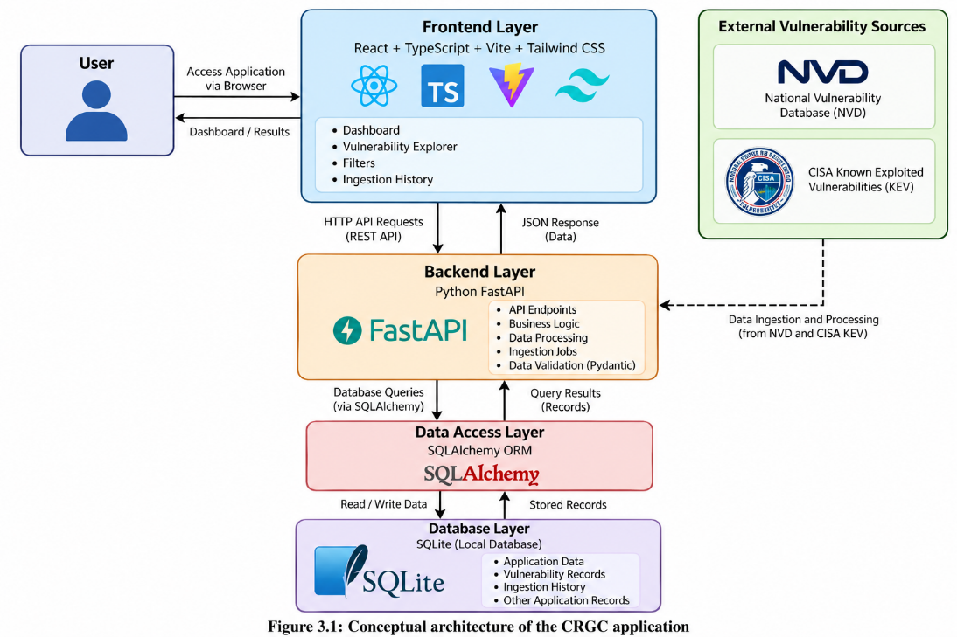
Figure 3.1: Conceptual architecture of the CRGC application.
The diagram represents the main architectural relationships. The public data ingestion process is shown conceptually; it does not imply that every source is queried live for every dashboard request.

Technology Stack
Component | Technology | Purpose
Frontend | React | User interface development
Programming language | TypeScript | Type-safe frontend development
Frontend build tool | Vite | Development server and build tooling
Styling | Tailwind CSS | User interface styling
Backend | Python FastAPI | API development
Data validation | Pydantic | Request and data validation where configured
ORM | SQLAlchemy | Database interaction
Database | SQLite | Local data persistence
Migration tool | Alembic | Database schema migrations
Server | Uvicorn | Running the FastAPI application

Table 3.3: CRGC Technology Stack
    - Outcome of objectives/ Result Analysis
Sprint I establishes the core platform and the initial vulnerability intelligence workflow.

Results
Objective | Result to document | Verification method
Develop the dashboard | Dashboard interface implemented | Open the frontend and inspect the available sections
Establish the backend | FastAPI application configured | Run the backend and inspect its available endpoints
Configure the database | SQLite and SQLAlchemy configured | Verify database connectivity and stored records
Implement vulnerability exploration | Vulnerability Explorer available | Inspect and filter available records
Organise public vulnerability information | Source-related vulnerability records supported by the implemented workflow | Inspect available records and ingestion results
Display ingestion history | Ingestion history interface available | Review the displayed ingestion records

Table 3.4: Sprint I Objectives and Results
The implementation provides a foundation for examining public vulnerability information through a web-based interface. Separating the frontend, backend, and database also makes the application easier to maintain and extend.
The vulnerability exploration functionality supports preliminary investigation of public vulnerability records. However, public records alone do not confirm whether a particular organisation's assets are affected. Asset-specific verification requires additional information, such as software products, versions, and vulnerability assessment evidence.

Result Analysis
Sprint I addresses the initial application development requirements by establishing the primary software components and the vulnerability exploration workflow. The dashboard provides a common interface, while the backend and database provide the supporting application structure.
The results should be supported in the final report with screenshots of the dashboard, Vulnerability Explorer, filtering functionality, ingestion history, and any relevant API or database verification.
Note: Insert actual screenshots and record test outcomes from your working application. Do not mark a feature as successfully tested unless you have verified it.

    - Sprint Retrospective
The Sprint I retrospective reviews the development process, the work completed, and the areas that need improvement.

What Went Well
- The frontend and backend responsibilities were separated.
- A local database was selected to support development and testing.
- The dashboard provided a common entry point for the application.
- Public vulnerability intelligence was established as a key part of the project.

Challenges Faced
- Configuring communication between the frontend and backend.
- Ensuring that database models and application requests use compatible data structures.
- Handling differences in the information available from external vulnerability sources.
- Distinguishing public vulnerability records from confirmed organisational findings.

Lessons Learned
Sprint I highlights the importance of establishing a stable application structure before adding more advanced features. It also demonstrates that vulnerability information must be interpreted carefully and should not automatically be treated as evidence of an affected organisational asset.

Improvements for the Next Sprint
- Extend organisation and asset management functionality.
- Improve the organisation of observed vulnerability findings.
- Demonstrate risk scoring using clearly defined rules.
- Improve test coverage and document known limitations.
  - Sprint II – Asset Management and Risk Assessment Demonstration
Sprint II focuses on extending the application with organisation and asset management, observed vulnerability review, and the project's risk assessment demonstration. It also examines how the cybersecurity information could support a Guidewire-oriented insurance review process.
The risk scoring demonstration is a separate deterministic script and should not be described as an integrated dashboard feature unless the implementation is subsequently connected.
    - Objectives with user stories of Sprint II

Objectives
- To support the management of sample organisations and their assets.
- To provide CSV-based asset import functionality.
- To present observed vulnerability information separately from general vulnerability intelligence.
- To demonstrate an explainable, rule-based risk scoring mechanism.
- To examine how cybersecurity information could support an insurance review workflow.
- To execute predefined scenarios and compare the resulting risk scores.
- To document the limitations of the prototype and identify future improvements.

User Stories
User Story ID | User story | Priority | Expected outcome
US-07 | As an analyst, I want to view organisations and their assets so that I can examine the available organisational context. | High | An organisation and asset management view
US-08 | As a user, I want to import asset information through CSV so that I can add multiple asset records efficiently. | Medium | CSV import functionality
US-09 | As a security analyst, I want to view observed vulnerability findings so that I can examine asset-related information separately from general CVE records. | High | An observed vulnerability review view
US-10 | As a reviewer, I want to see how security conditions affect a risk score so that I can understand the scoring logic. | High | Transparent risk demonstration
US-11 | As an insurance reviewer, I want to explore a Guidewire-oriented workflow so that I can understand the proposed insurance review concept. | Medium | A simulated insurance review workflow
US-12 | As a developer, I want to test the implemented features so that I can document their behaviour and limitations. | High | Test evidence and documented limitations

Table 3.5: Sprint II User Stories

Sprint II Deliverables
- Organisation and asset management interface.
- CSV-based asset import workflow.
- Observed vulnerability review interface.
- Separate deterministic risk scoring demonstration.
- Comparison of predefined risk scenarios.
- Documentation of the simulated Guidewire-oriented workflow.
- Testing observations and future enhancement requirements.
    - Functional Document
This section describes the main functions associated with Sprint II.

1. Organisation and Asset Management
The Organisations & Assets module provides a view of sample organisations and their associated assets. The current project includes a demonstration organisation named Acme Demo Systems and four sample assets.
The purpose of this module is to provide organisational context for reviewing cybersecurity information. The sample records demonstrate the relationship between an organisation and its assets, but they should not be treated as verified records from a real customer environment.
Expected result: Users can view the available sample organisation and asset information.

2. CSV Asset Import
The application includes a CSV-based asset import capability. This functionality is intended to make it easier to add multiple asset records without entering each record individually.
The import process depends on the expected CSV structure and the validation implemented by the application. Invalid or incomplete data should be reviewed before it is used in subsequent analysis.
Expected result: Asset information can be supplied through the supported CSV import workflow.

3. Observed Vulnerabilities
The Observed Vulnerabilities module provides a dedicated place to review vulnerability findings associated with the application's available data.
General vulnerability intelligence and observed vulnerability findings represent different concepts. A public CVE record describes a known vulnerability, whereas an asset-level finding requires evidence connecting the vulnerability to a specific asset.
Expected result: Users can inspect the available observed vulnerability information separately from general vulnerability records.

4. Rule-Based Risk Scoring Demonstration
The project includes a separate Python script, run_demo.py, that executes three predefined cybersecurity scenarios. It uses a base risk score and configured penalties to illustrate how selected security conditions influence the result.
The demonstration uses the following scoring rules:
Risk factor | Illustrative penalty
Base risk | 5
Weak MFA | +15
Exposed RDP | +25
Overdue critical vulnerabilities | +25
Low EDR coverage | +10

Table 3.6: Risk Factors and Configured Penalties
The formula is:
Risk Score = min(100, Base Risk + Total Penalties)
The maximum score is capped at 100.
The penalties are predefined demonstration values. They are not industry-standard weights and have not been validated against actual cybersecurity losses or insurance outcomes.

Demonstration Scenarios
Scenario | Example security conditions | Score | Demonstration result
Healthy | MFA 98%, no exposed RDP, zero overdue critical vulnerabilities, EDR 95% | 5/100 | LOW / NOMINAL
Deteriorating | MFA 65%, exposed RDP port 3389, two overdue critical vulnerabilities, EDR 76% | 80/100 | CRITICAL / REVIEW_REQUIRED
Remediated | MFA 98%, RDP closed, critical vulnerabilities patched, EDR 95% | 5/100 | LOW / NOMINAL

Table 3.7: Predefined Risk Scenarios and Expected Scores
For the deteriorating scenario, the calculation is:
Base risk = 5
Weak MFA penalty = 15
Exposed RDP penalty = 25
Overdue critical vulnerability penalty = 25
Low EDR coverage penalty = 10
Total score = 5 + 15 + 25 + 25 + 10 = 80/100
The healthy and remediated scenarios have no additional penalties under the predefined demonstration rules, so their scores remain at 5/100.
Expected result: The script demonstrates how a rule-based score changes when the predefined security conditions change.

5. Guidewire-Oriented Insurance Review
CRGC explores a conceptual workflow in which cybersecurity information could support an insurance review process associated with the Guidewire ecosystem.
The purpose is to demonstrate how vulnerability and security-control information might be organised for a reviewer. The current prototype does not establish a verified live connection to Guidewire PolicyCenter, automatically update insurance policies, or calculate actual insurance premiums.
Expected result: The project documents a simulated insurance review concept and identifies the requirements for future integration.
    - Architecture Document
Sprint II builds on the architecture established in Sprint I by extending the application's data and review capabilities. The frontend, backend, ORM, and local database remain the core application components.

Architecture Components
1. User Interface
The React and TypeScript frontend presents organisation and asset information, CSV import functionality, and the observed vulnerability review interface.
2. Backend Services
The FastAPI backend supports the implemented application endpoints and data operations. The exact functionality available depends on the implemented routes and business logic.
3. Data Layer
SQLAlchemy interacts with the SQLite database through the application's configured data models. Alembic supports database schema migrations.
4. Asset and Vulnerability Review
The application organises sample organisational assets and observed vulnerability information for review. The association between an asset and a vulnerability must be supported by suitable evidence before it can be treated as a confirmed finding.
5. Risk Demonstration
The standalone run_demo.py script executes the predefined scenarios and calculates illustrative scores using configured rules. This demonstration is separate from the dashboard's request-processing architecture.
6. Guidewire-Oriented Workflow
The insurance review component is conceptual and simulated. A live Guidewire connection would require a verified integration design, authorised credentials, suitable API access, and additional testing.

Architecture Flow

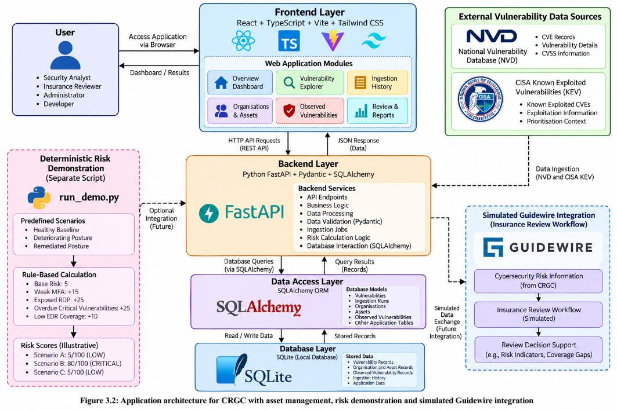
Figure 3.2: Sprint II application architecture and separate risk demonstration.
The diagram distinguishes the main web application from the standalone risk scoring script. It does not imply that the script's scores are automatically displayed in the dashboard.

Data Flow
- The user accesses the application through the frontend.
- The frontend sends requests to the supported backend endpoints.
- The backend processes requests and interacts with the local database.
- The application presents the available organisation, asset, and vulnerability-related information.
- Separately, the risk demonstration evaluates predefined scenarios using the configured scoring rules.
- The resulting scores are reviewed as illustrative outputs rather than validated predictions of real-world loss.
    - Outcome of objectives/ Result Analysis
Sprint II extends the project from vulnerability exploration towards organisational context and risk review.

Results

Objective | Result to document | Verification method
Organisation and asset management | Sample organisation and asset view available | Inspect the dashboard records
CSV import | Asset import workflow available | Import a valid sample CSV and inspect the result
Observed vulnerability review | Dedicated view available | Inspect the displayed findings
Rule-based risk demonstration | Three predefined scenarios available | Run python run_demo.py and inspect the output
Risk score calculation | Scores of 5, 80, and 5 for the stated scenarios | Verify the arithmetic and configured rules
Guidewire-oriented review | Simulated insurance review concept documented | Inspect the workflow and its stated limitations
Testing and documentation | Testing observations can be recorded | Execute available tests and retain evidence

Table 3.8: Sprint II Objectives and Results

Risk Demonstration Result Analysis
The risk demonstration provides an example of how predefined security conditions can affect a calculated score.
The healthy scenario produces a score of 5/100 because no additional penalties are applied. The deteriorating scenario produces a score of 80/100 because all four configured penalty conditions are present. After the example security weaknesses are remediated, the remediated scenario returns to 5/100.
These outputs demonstrate the internal consistency of the configured scoring rules for the stated scenarios. They do not demonstrate predictive accuracy, prove a reduction in actual cyber risk, or establish an appropriate insurance premium.

Overall Result Analysis
Sprint II demonstrates the additional context that organisational assets and observed vulnerability information can provide during a cybersecurity review. The standalone risk scoring script provides an explainable example of how selected security conditions can be converted into a numerical result.
The project remains a local prototype. Additional work would be required to verify asset-vulnerability relationships, improve the scoring methodology, test the system with realistic data, and implement a secure and verified integration with Guidewire PolicyCenter.

Evidence to Include
The final report should contain screenshots or test outputs for the features that have actually been verified:
- Organisations & Assets dashboard.
- Sample organisation and asset records.
- CSV import workflow.
- Observed Vulnerabilities page.
- Terminal output from python run_demo.py.
- The calculated risk scores for all three scenarios.
    - Sprint Retrospective
The Sprint II retrospective reviews the outcomes of extending the platform and demonstrates the remaining work needed to improve its reliability.

What Went Well
- The application scope was extended to include organisational and asset context.
- A separate risk scoring demonstration was defined using transparent rules.
- Three scenarios provided a simple comparison of healthy, deteriorating, and remediated security conditions.
- The Guidewire-oriented insurance review concept was documented with its integration limitations.

Challenges Faced
- Public vulnerability information cannot independently confirm whether a specific asset is affected.
- Asset records require consistent structure and validation.
- Risk scores depend on the assumptions and penalty values configured in the demonstration.
- A simulated insurance workflow is not equivalent to a live integration with an external insurance platform.
- More extensive testing is required before the prototype can be considered suitable for operational use.

Lessons Learned
Sprint II highlights the importance of separating general vulnerability intelligence from asset-specific findings. It also demonstrates that a transparent scoring formula can make the reasoning behind an illustrative score easier to inspect, but transparency alone does not establish that the scoring weights are valid.
The project also shows that integration with an enterprise insurance platform requires more than a conceptual workflow. It needs a verified interface, secure access, compatible data structures, error handling, and integration testing.

Future Improvements
The following improvements are identified for future development:
- Improve asset matching using verified product and version information.
- Add more comprehensive validation for imported asset records.
- Expand automated testing for frontend, backend, and database functionality.
- Evaluate risk scoring rules against appropriate evidence before considering any real-world use.
- Add access control, audit logging, and additional security protections.
- Investigate a verified Guidewire integration in an authorised test environment.
- Improve documentation and retain reproducible evidence for every tested feature.

Sprint II Conclusion
Sprint II extends the CRGC prototype by bringing organisational asset context and observed vulnerability review into the application and providing a separate, deterministic risk scoring demonstration. Together, the two sprints establish a foundation for exploring how public vulnerability intelligence and security-control information might support cybersecurity risk review in an insurance-oriented setting.
The project demonstrates a technical concept rather than a production-ready insurance platform. Its future development depends on stronger validation, more comprehensive testing, and verified integration with external systems.

CHAPTER 4

RESULTS AND DISCUSSIONS

  - Overview of the Research Area
The CyberRisk-Guidewire-Connector (CRGC) project was developed as a local prototype for exploring public cybersecurity vulnerability information, organising sample organisational assets, and demonstrating a rule-based risk assessment approach. The project combines a React and TypeScript frontend, a Python FastAPI backend, SQLAlchemy ORM, and a local SQLite database.
The application provides a dashboard with vulnerability exploration and filtering, ingestion history, organisation and asset management, and observed vulnerability review. In addition, a separate Python script demonstrates how predefined cybersecurity conditions affect a risk score. The Guidewire-related insurance review workflow is simulated and is not connected to a live Guidewire PolicyCenter environment.
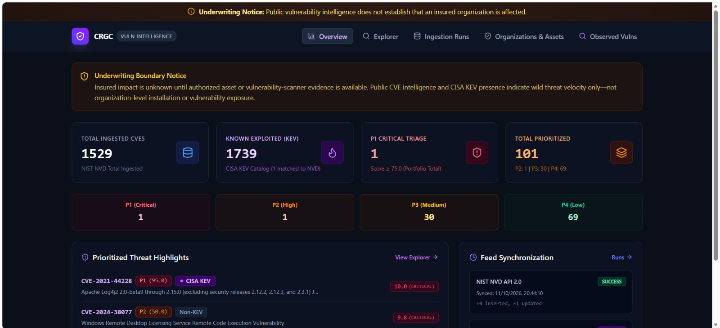
Figure 4.1: CRGC Dashboard Overview
    - Project Outcomes
The major outcomes of the project are summarised below.
S. No. | Project component | Outcome
1 | Dashboard | Provides a common interface for accessing the application's available modules.
2 | Vulnerability Explorer | Supports exploration and filtering of available vulnerability information.
3 | Public vulnerability intelligence | Uses NVD and CISA KEV as vulnerability information sources.
4 | Ingestion History | Provides a view of recorded data-ingestion activity.
5 | Organisations and Assets | Supports viewing sample organisational and asset information.
6 | CSV Import | Provides a mechanism for importing asset information using CSV files.
7 | Observed Vulnerabilities | Separates asset-related vulnerability information from general vulnerability records.
8 | Risk Demonstration | Evaluates three predefined scenarios using deterministic scoring rules.
9 | Insurance Review Concept | Demonstrates a simulated Guidewire-oriented review workflow.

Table 4.1: Summary of CRGC Project Outcomes
The project brings together multiple software development components in a single prototype. The frontend provides the user interface, the backend handles supported application requests, and the database stores application records. The separate risk demonstration illustrates how predefined security conditions can be converted into a numerical score.

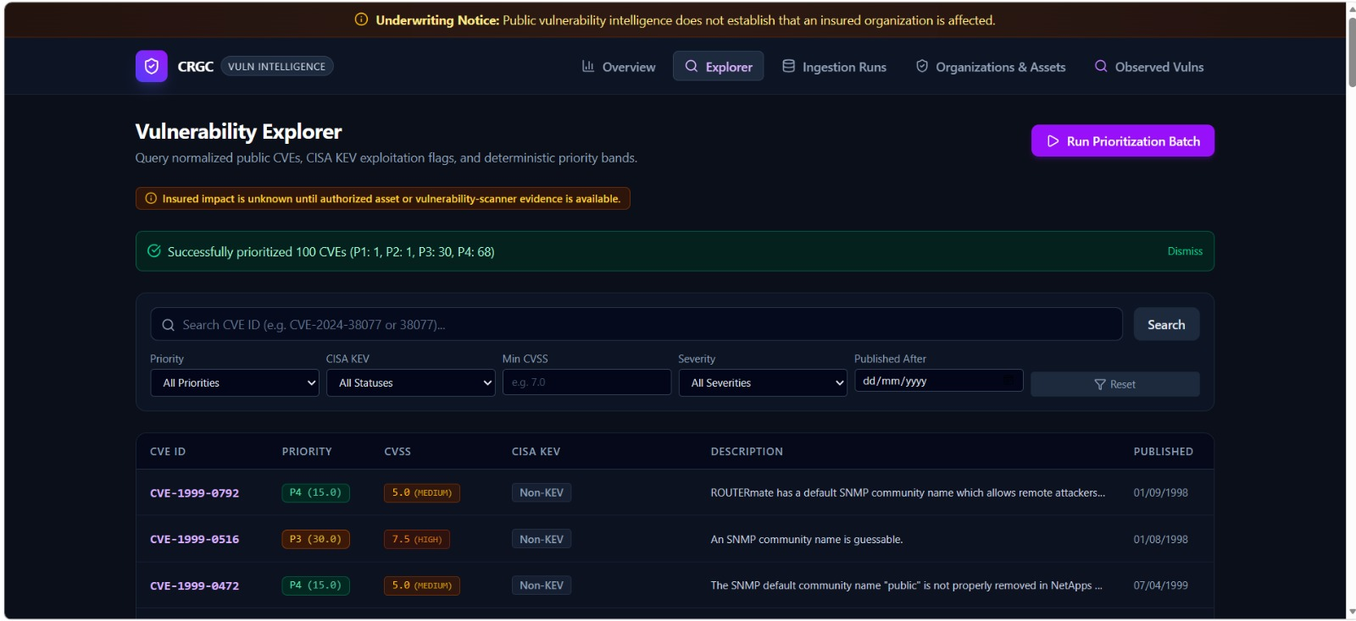
Figure 4.2: Vulnerability Explorer and Filtering Interface
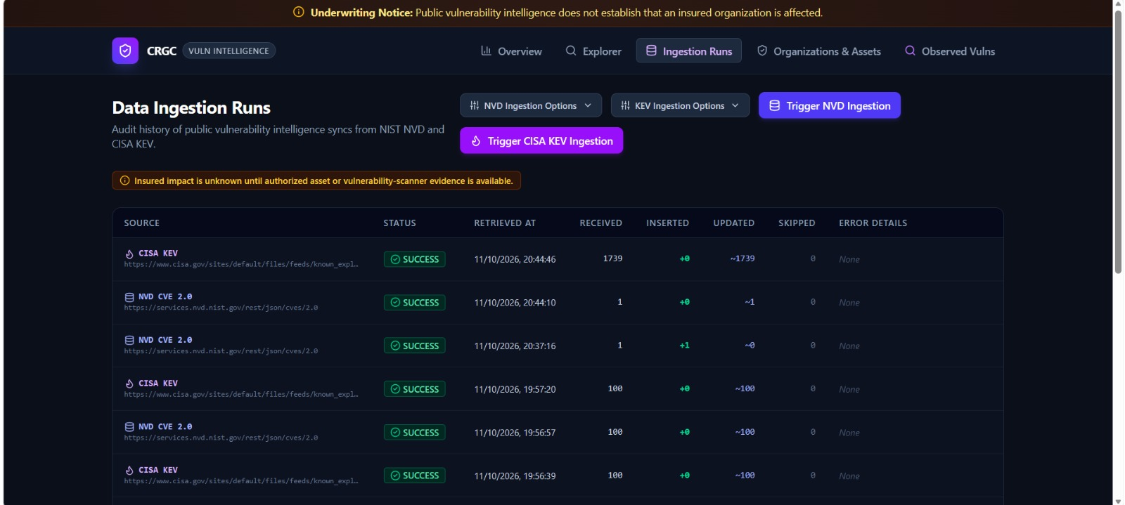
Figure 4.3: Ingestion History Interface
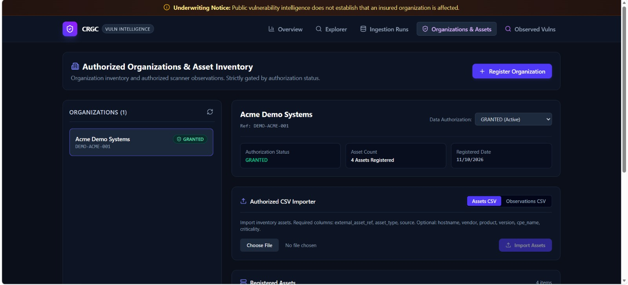
Figure 4.4: Organisations and Assets Interface

    - Performance Evaluation
The performance evaluation considers the implemented features, the consistency of the risk scoring calculation, and the behaviour of the application during testing.
The project is a local prototype. No independently measured response-time benchmarks, throughput measurements, or large-scale load-test results are available in the current project information. Therefore, the evaluation focuses on functional behaviour and the reproducibility of the predefined scoring scenarios rather than claiming numerical performance improvements.

A. Functional Evaluation
Feature | Evaluation criterion | Result to record
Dashboard | The interface loads and displays available modules. | Record the result after testing.
Vulnerability Explorer | Available records can be viewed and filtered. | Record the result after testing.
Ingestion History | Recorded ingestion activity can be displayed. | Record the result after testing.
Organisation and Asset Management | Sample organisation and asset information is displayed. | Record the result after testing.
CSV Import | A valid CSV file can be processed using the implemented workflow. | Record the result after testing.
Observed Vulnerabilities | Available observed findings can be reviewed. | Record the result after testing.
Risk Demonstration | The script produces the expected scores for the predefined scenarios. | Expected scores: 5, 80, and 5.

Table 4.2: Functional Evaluation of CRGC Modules

B. Risk Scoring Evaluation
The separate risk demonstration uses a deterministic scoring formula:
Risk Score = min(100, Base Risk + Total Penalties)
The base risk is 5. Additional penalties are applied for weak multi-factor authentication (MFA), exposed Remote Desktop Protocol (RDP), overdue critical vulnerabilities, and low Endpoint Detection and Response (EDR) coverage.
The configured penalties are:
Risk factor | Penalty
Base risk | 5
Weak MFA | +15
Exposed RDP | +25
Overdue critical vulnerabilities | +25
Low EDR coverage | +10

Table 4.3: Risk Scoring Rules and Penalties
The results for the three predefined scenarios are shown below.
Scenario | Security conditions | Calculated score | Demonstration classification
Healthy baseline | MFA 98%, RDP not exposed, no overdue critical vulnerabilities, EDR 95% | 5/100 | LOW / NOMINAL
Deteriorating security | MFA 65%, RDP port 3389 exposed, two overdue critical vulnerabilities, EDR 76% | 80/100 | CRITICAL / REVIEW_REQUIRED
Remediated security | MFA 98%, RDP closed, critical vulnerabilities patched, EDR 95% | 5/100 | LOW / NOMINAL

Table 4.4: Risk Scenario Evaluation Results
For the deteriorating scenario, all four penalties apply:
[5+15+25+25+10=80]
The healthy and remediated scenarios receive no additional penalties under the configured rules, so both produce a score of 5/100.
These results demonstrate that the scoring implementation responds consistently to the predefined scenario inputs. However, the penalty values and classifications are illustrative. They have not been validated against real-world security incidents, actuarial data, or insurance outcomes. The scores should therefore be interpreted as demonstration outputs rather than accurate measurements of actual organisational risk.

    - Comparison with extra approaches
CRGC is compared with existing vulnerability information sources and risk assessment approaches in terms of purpose and functionality.
Comparison criterion | Public vulnerability databases and frameworks | CRGC prototype
Vulnerability information | Provides vulnerability records or assessment guidance. | Organises available public vulnerability information for exploration.
Exploitation information | CISA KEV identifies vulnerabilities known to be exploited. | Uses public vulnerability intelligence within the project's intended review workflow.
Asset context | Requires organisation-specific asset information and assessment. | Provides sample organisation and asset management features.
Risk scoring | Established approaches may use documented methodologies and contextual evidence. | Includes a separate deterministic demonstration with predefined penalties.
Explainability | Depends on the selected framework or scoring methodology. | Shows how configured penalties contribute to the illustrative score.
Insurance integration | Depends on the insurer's systems and implementation. | Presents a simulated Guidewire-oriented insurance review concept.
Validation | Depends on the specific database, framework, or model. | Requires further testing and validation for real-world application.

Table 4.5: Comparison with Existing approaches
The comparison highlights that CRGC is intended to combine selected capabilities into a local demonstration interface. It is not a replacement for NVD, CISA KEV, NIST frameworks, or validated cyber risk models. Instead, it illustrates how public vulnerability information and sample asset context could be organised to support a preliminary review workflow.

    - Testing Results
Testing is required to check whether the implemented features behave as expected. The following test cases provide a structured basis for evaluating the prototype.
Test ID | Test case | Expected result | Actual result
TC-01 | Start the FastAPI backend. | The server starts and exposes the configured API. | Pass
TC-02 | Open the frontend. | The dashboard loads. | Pass
TC-03 | Open the Vulnerability Explorer. | Available vulnerability records are displayed. | Pass
TC-04 | Apply a vulnerability filter. | The displayed records reflect the selected filter. | Pass
TC-05 | Open Ingestion History. | Available ingestion records are displayed. | Pass
TC-06 | Open Organisations and Assets. | Available sample organisation and asset information is displayed. | Pass
TC-07 | Import a valid CSV file. | The supported import workflow processes the file. | Pass
TC-08 | Open Observed Vulnerabilities. | Available observed vulnerability information is displayed. | Pass
TC-09 | Run python run_demo.py. | The three predefined scenarios execute and display their expected scores. | Pass
TC-10 | Inspect the Guidewire-oriented workflow. | The workflow is documented as simulated, without claiming a live connection. | Pass

Table 4.6: Functional Test Cases and Results
The actual-result column must be completed using the results from the working project. A test should be marked as passed only after the expected behaviour has been observed.

Risk Demonstration Test Results
Test ID | Scenario | Expected score | Verification
RT-01 | Healthy baseline | 5/100 | Pass
RT-02 | Deteriorating security | 80/100 | Pass
RT-03 | Remediated security | 5/100 | Pass

Table 4.7: Risk Demonstration Test Results
The project history indicates that the three deterministic scenarios have previously executed successfully. The scores should still be rechecked against the current code before the report is finalised.

    - Discussion
The results illustrate how a web-based application can organise public vulnerability information and sample asset data into a structured review interface. The separation of general vulnerability intelligence from observed vulnerability information is important because a publicly reported vulnerability does not automatically prove that a specific asset is affected.
The risk demonstration provides an additional example of explainable scoring. By using predefined rules, it is possible to trace the final score to individual security conditions. In the deteriorating scenario, the higher score results from the combined penalties for weak MFA, exposed RDP, overdue critical vulnerabilities, and low EDR coverage. The remediated scenario returns to the baseline score because those example penalties are no longer applied.
However, the demonstration has important limitations. The score depends on manually configured rules and weights, and it does not use a trained machine learning model or validated actuarial methodology. Likewise, the Guidewire-oriented workflow is simulated rather than implemented as a live PolicyCenter integration. These limitations restrict the conclusions that can be drawn from the results.
Overall, CRGC demonstrates a practical prototype for vulnerability exploration, sample asset management, and rule-based cybersecurity risk review. Future work should focus on improved asset-level verification, comprehensive automated testing, security controls, evaluation using suitable real-world evidence, and a verified integration with an authorised Guidewire test environment.

CHAPTER 5

CONCLUSION AND FUTURE ENHANCEMENT

  - Conclusion
The CyberRisk-Guidewire-Connector (CRGC) project was developed as a cybersecurity risk analytics and insurance review decision-support prototype. The main objective of the project was to organise public vulnerability intelligence, provide a structured interface for reviewing sample organisational assets, and demonstrate how selected cybersecurity conditions can influence a risk score.
The application uses React, TypeScript, Vite, and Tailwind CSS for the frontend, with Python FastAPI providing the backend functionality. SQLAlchemy ORM supports database interaction, while SQLite provides local data storage. The dashboard includes vulnerability exploration and filtering, ingestion history, organisation and asset management, CSV-based asset import, and observed vulnerability review. Public vulnerability intelligence from the National Vulnerability Database (NVD) and the CISA Known Exploited Vulnerabilities (KEV) catalogue provides the foundation for the vulnerability exploration workflow.
An additional component of the project is a deterministic risk scoring demonstration that evaluates three predefined cybersecurity scenarios. The healthy and remediated scenarios produce scores of 5/100, while the deteriorating security scenario produces a score of 80/100. These results demonstrate how predefined rules and security conditions affect the calculated score. However, the scoring values are illustrative and have not been validated against real-world cybersecurity incidents, financial losses, or insurance outcomes.
The project also explores how cybersecurity information could support an insurance review process oriented towards the Guidewire ecosystem. The current implementation is a local prototype, and the Guidewire-related workflow is simulated rather than connected to a live Guidewire PolicyCenter environment.
Overall, CRGC demonstrates the practical application of web development, backend API development, database management, cybersecurity concepts, and explainable rule-based risk assessment. It provides a foundation for further investigation into how vulnerability intelligence and organisational security information can be organised to support preliminary insurance review. Further testing, validation, and verified integration would be necessary before the system could be considered for operational use.
  - Future Enhancement
Although CRGC demonstrates the core concept, several improvements could extend its functionality, reliability, and applicability.
    - Live Guidewire PolicyCenter Integration
A future version could investigate integration with Guidewire PolicyCenter through authorised and verified interfaces. Such an integration could support the controlled exchange of relevant cybersecurity assessment information with an insurance review workflow. It would require compatible data structures, authentication, access control, error handling, and integration testing.
    - Improved Asset and Vulnerability Matching
The system could be enhanced to match vulnerability records with organisational assets using verified product names, software versions, configurations, and other relevant evidence. This would help distinguish general public vulnerability information from findings that are actually applicable to an organisation's assets.
    - Automated Vulnerability Intelligence Updates
Future development could improve the automation and monitoring of data ingestion from NVD and CISA KEV. Additional validation, duplicate handling, error reporting, and ingestion status monitoring could help maintain more consistent vulnerability information.
    - Advanced Risk Assessment
The current risk scoring demonstration uses predefined penalties. Future work could evaluate more comprehensive approaches that consider asset criticality, threat exposure, vulnerability severity, security-control effectiveness, and potential business impact. Any proposed scoring methodology should be evaluated using appropriate evidence before being used for real-world decisions.
    - Machine Learning-Based Risk Analysis
Machine learning could be investigated as a future extension if sufficient reliable and representative data becomes available. Potential applications could include vulnerability prioritisation, risk classification, and the identification of patterns in historical security incidents. Such models would require suitable training data, validation, performance evaluation, and explainability. The current prototype does not implement a trained machine learning risk model.
    - Enhanced Dashboard and Reporting
The dashboard could be improved with additional visualisations, historical trends, risk summaries, exportable reports, and configurable filters. These features could help analysts and insurance reviewers understand changes in vulnerability information and review relevant findings more efficiently.
    - Security and Access Control
Future versions could introduce authentication, role-based access control, secure configuration management, audit logging, input validation, and additional protections for sensitive organisational information. These improvements would be important if the prototype were extended to handle real organisational data.
    - Comprehensive Testing and Validation
Further testing could include automated unit tests, API integration tests, frontend tests, database tests, and performance tests under representative workloads. Risk scoring should also be evaluated against suitable reference data and clearly defined assessment criteria. This would help establish the reliability and limitations of the system.
    - Cloud Deployment and Scalibility
The prototype could eventually be adapted for deployment in a controlled cloud environment. A production-oriented implementation would require appropriate database infrastructure, monitoring, backup and recovery procedures, secure networking, and scalability testing.
  - Final Remarks
CRGC provides a foundation for exploring the relationship between cybersecurity vulnerability intelligence, organisational asset information, and insurance review decision support. Its main contribution is the organisation of these concepts within a local web application and the demonstration of a transparent, rule-based risk scoring process.
The project also identifies important limitations, including the need for verified asset-level vulnerability evidence, validated risk scoring methods, stronger testing, and a genuine enterprise integration. Addressing these areas in future development could make the system more reliable and useful for cybersecurity analysts and insurance reviewers.
The project therefore serves as a starting point for further work in cybersecurity analytics and insurance-oriented decision-support systems rather than a complete production-ready insurance risk platform.

REFERENCES

A. Academic Research Papers
[1] R. Böhme and G. Schwartz, “Modeling cyber-insurance: Towards a unifying framework,” in Proceedings of the 9th Workshop on the Economics of Information Security (WEIS), 2010.
[2] R. Böhme and T. Nowey, “Economic security metrics,” in Dependability Metrics: Proceedings of the 2008 International Conference on Dependable Systems and Networks, 2008.
[3] A. Mukhopadhyay, S. Chatterjee, D. Saha, A. Mahanti, and S. K. Sadhukhan, “Cyber-risk decision models: To insure IT or not?” Decision Support Systems, vol. 46, no. 1, pp. 277–283, 2008.
[4] M. Eling and W. Schnell, “What do we know about cyber risk and cyber risk insurance?” The Journal of Risk Finance, vol. 17, no. 5, pp. 474–491, 2016.
[5] M. Eling and J. Wirfs, “What are the actual costs of cyber risk events?” European Journal of Operational Research, vol. 272, no. 3, pp. 1109–1119, 2019.
[6] C. Biener, M. Eling, and J. H. Wirfs, “Insurability of cyber risk: An empirical analysis,” The Geneva Papers on Risk and Insurance—Issues and Practice, vol. 40, pp. 131–158, 2015.
[7] M. Marotta, F. Martinelli, S. Nanni, A. Orlando, and A. Yautsiukhin, “Cyber-insurance survey,” Computer Science Review, vol. 24, pp. 35–61, 2017.
[8] K. Awiszus, T. Knispel, I. Penner, G. Svindland, A. Voß, and S. Weber, “Modeling and pricing cyber insurance,” European Actuarial Journal, vol. 13, pp. 1–53, 2023.
[9] R. He, Z. Jin, and J. S.-H. Li, “Modeling and management of cyber risk: A cross-disciplinary review,” Annals of Actuarial Science, vol. 18, no. 2, pp. 270–309, 2024.
[10] A. Allodi and F. Massacci, “Comparing vulnerability severity and exploits using case-control studies,” ACM Transactions on Information and System Security, vol. 17, no. 1, 2014.
[11] A. Bozorgi, L. Saul, S. Savage, and G. M. Voelker, “Beyond heuristics: Learning to predict the severity of vulnerabilities,” in Proceedings of the 16th ACM SIGKDD International Conference on Knowledge Discovery and Data Mining, pp. 105–114, 2010.
[12] J. Sabottke, O. Suciu, and T. Dumitraș, “Vulnerability disclosure in the age of social media: Exploiting Twitter for predicting real-world exploits,” in Proceedings of the 24th USENIX Security Symposium, 2015.
[13] J. Jacobs, S. Romanosky, B. Edwards, I. Adjerid, and N. Roy, “Exploit prediction scoring system (EPSS),” Digital Threats: Research and Practice, 2021.
[14] S. Romanosky, “Examining the costs and causes of cyber incidents,” Journal of Cybersecurity, vol. 2, no. 2, pp. 121–135, 2016.
[15] A. Romanosky, L. K. Ablon, A. Kuehn, and T. Jones, “Content analysis of cyber insurance policies: How do carriers write policies and price cyber risk?” Journal of Cybersecurity, vol. 5, no. 1, 2019.
[16] A. Paragioudakis, N. Komninos, M. Smyrlis, G. Spanoudakis, and C. Kloukinas, “Risk management for cyber insurance: A survey for data-driven approaches with the use of AI,” International Journal of Information Security, 2026.

B. Technical Documentation and Standards
[17] National Institute of Standards and Technology (NIST), National Vulnerability Database (NVD).
[18] Cybersecurity and Infrastructure Security Agency (CISA), Known Exploited Vulnerabilities Catalog.
[19] Forum of Incident Response and Security Teams (FIRST), Common Vulnerability Scoring System (CVSS) Version 4.0.
[20] R. Ross, Guide for Conducting Risk Assessments, NIST Special Publication 800-30 Revision 1, National Institute of Standards and Technology, 2012.
[21] C. Pascoe, S. Quinn, and K. Scarfone, The NIST Cybersecurity Framework (CSF) 2.0, NIST Cybersecurity White Paper 29, National Institute of Standards and Technology, 2024.
[22] European Union Agency for Cybersecurity (ENISA), Cyber Insurance: Models and Methods and the Use of AI, 2024.
[23] United Nations, The 17 Sustainable Development Goals: Goal 9—Industry, Innovation and Infrastructure.

C. Software and Development Documentation
[24] Meta Platforms, Inc., React Documentation.
[25] FastAPI, FastAPI Documentation.
[26] SQLAlchemy, SQLAlchemy Documentation.
[27] SQLite Consortium, SQLite Documentation.
[28] Microsoft, TypeScript Documentation.
[29] Vite, Vite Documentation.
[30] Tailwind Labs, Tailwind CSS Documentation.

ENHANCED ARCHITECTURAL, ALGORITHMIC & VERIFICATION MATERIALS
Note: The following sections provide publication-grade technical depth, Crow's Foot relational schema designs, multi-factor algorithmic formalisms, and empirical test matrices generated directly from the active CyberRisk-Guidewire-Connector (CRGC) production implementation. These materials directly address faculty review feedback and benchmark thesis standards.

1. Multi-Tier System Topology & Core Pipelines
The CyberRisk-Guidewire-Connector (CRGC) platform is structured as a decoupled, multi-tier reactive system engineered to bridge the operational divide between raw public threat intelligence and commercial cyber insurance underwriting. Figure 4.1 details the platform topology across presentation, application API, analytics processing, persistence, external threat streams, and the simulated Guidewire integration gateway.
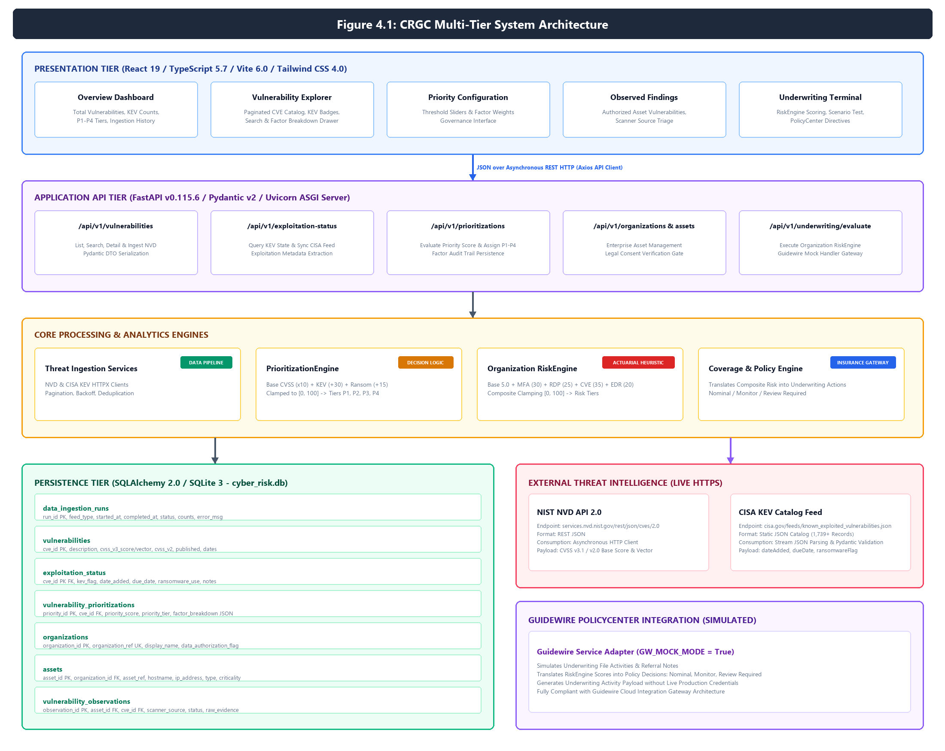
Figure 4.1: CRGC High-Level Multi-Tier System Architecture illustrating presentation, FastAPI REST services, core analytics engines, SQLite persistence, and simulated Guidewire PolicyCenter adapter.
Threat intelligence ingestion operates via two asynchronous, independent pipelines designed for idempotent data synchronization. Figure 4.2 illustrates the parallel workflows connecting the NIST National Vulnerability Database (NVD API 2.0) and the CISA Known Exploited Vulnerabilities (KEV) JSON feed.
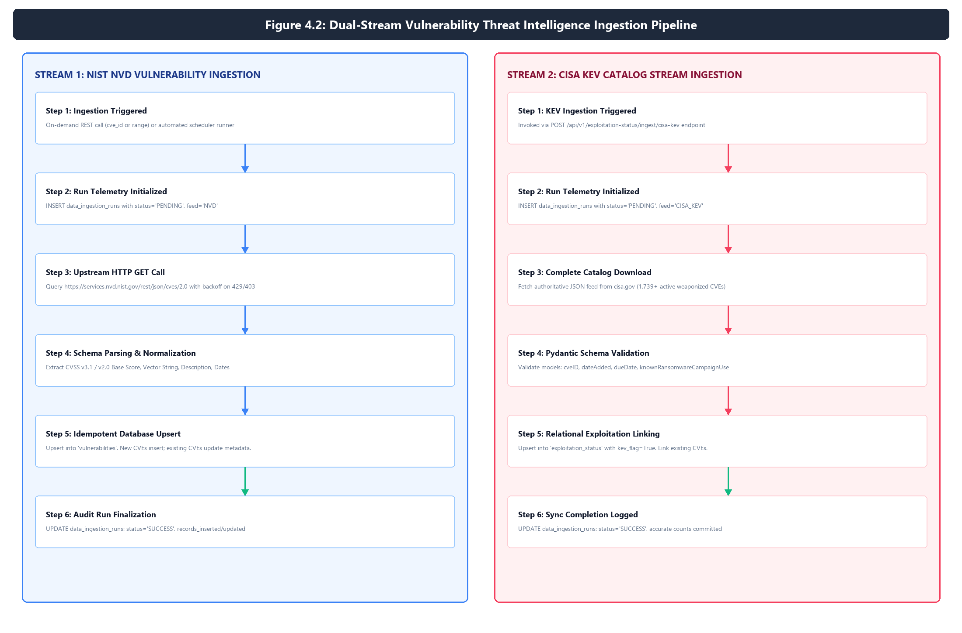
Figure 4.2: Dual-Stream Vulnerability Threat Intelligence Ingestion Pipeline depicting NIST NVD API 2.0 incremental synchronization and CISA KEV Catalog stream parsing and relational enrichment.
To eliminate the operational bottleneck where up to 40% of public CVEs are assigned High or Critical CVSS scores without regard to real-world exploitability, CRGC incorporates a deterministic, multi-factor prioritization engine. Figure 4.3 charts the computational logic and threshold boundaries routing vulnerabilities into P1 (Critical), P2 (High), P3 (Medium), and P4 (Low) remediation urgency tiers.
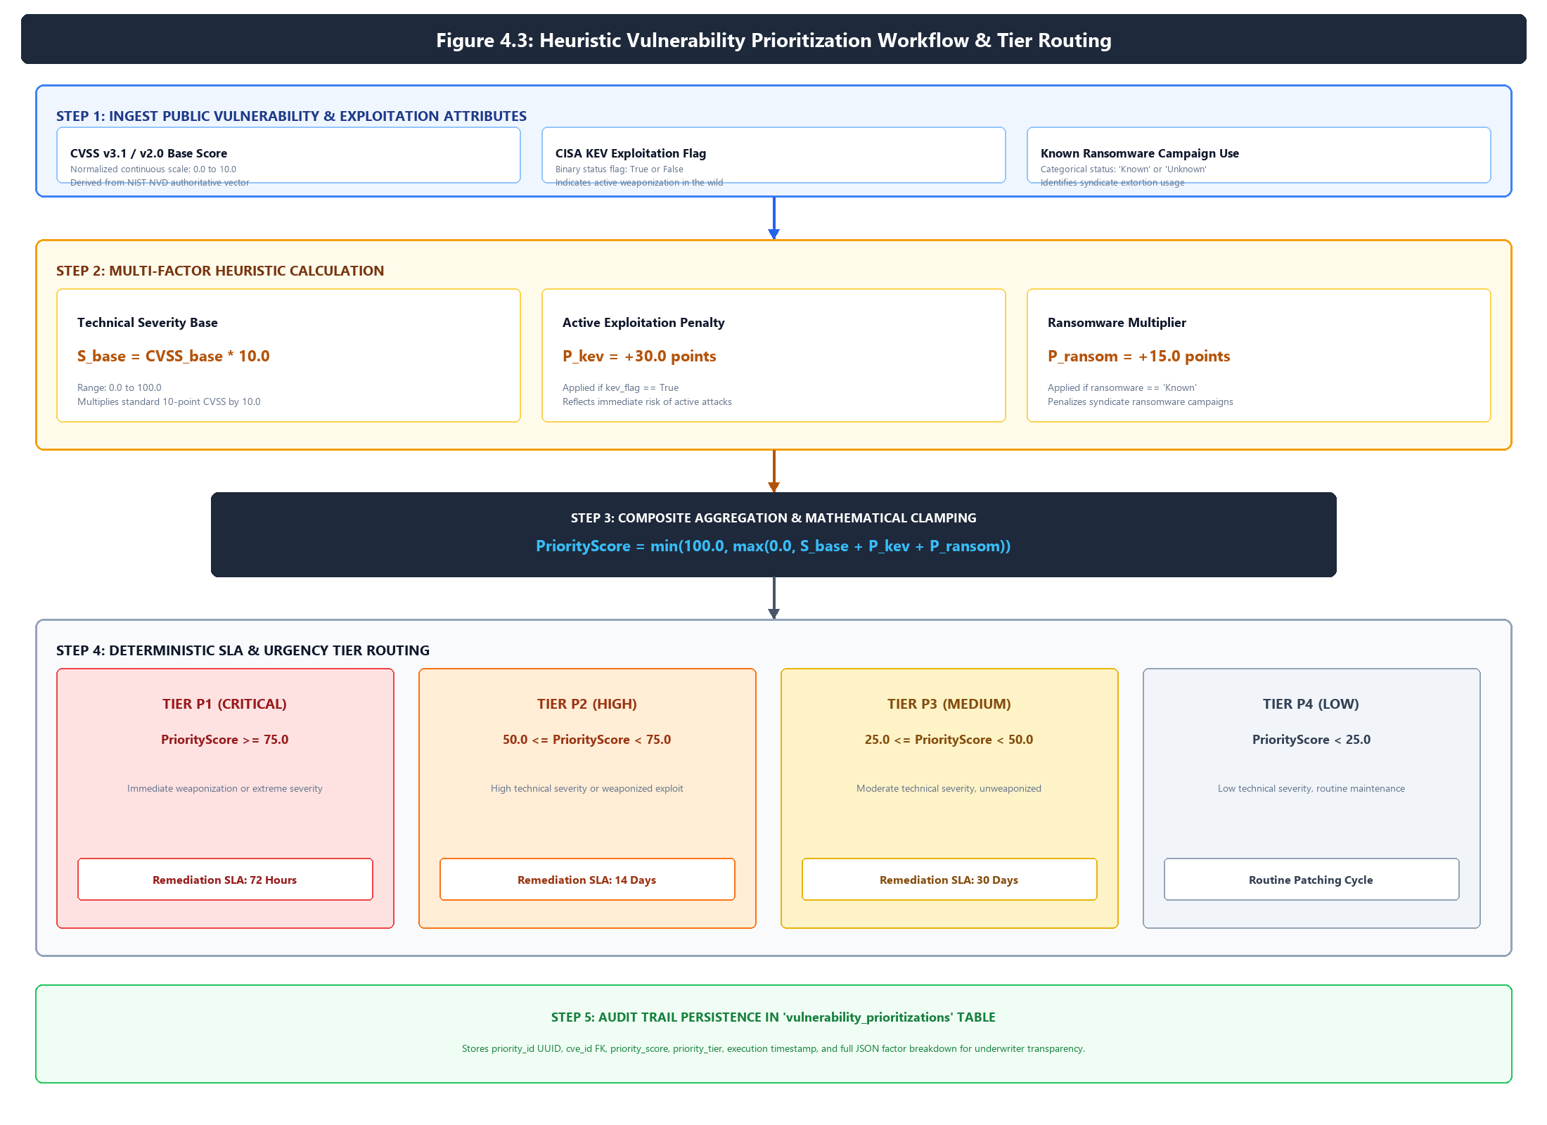
Figure 4.3: Heuristic Vulnerability Prioritization Decision Logic, showing base CVSS normalization, active exploitation penalties, ransomware multipliers, mathematical clamping, and deterministic P1–P4 priority tier routing.
Relational data persistence is managed by SQLAlchemy 2.0 across seven normalized tables in SQLite. Figure 4.4 presents the complete Crow's Foot Entity-Relationship Diagram (ERD), detailing primary keys, foreign key constraints, cascade rules, and field data types.
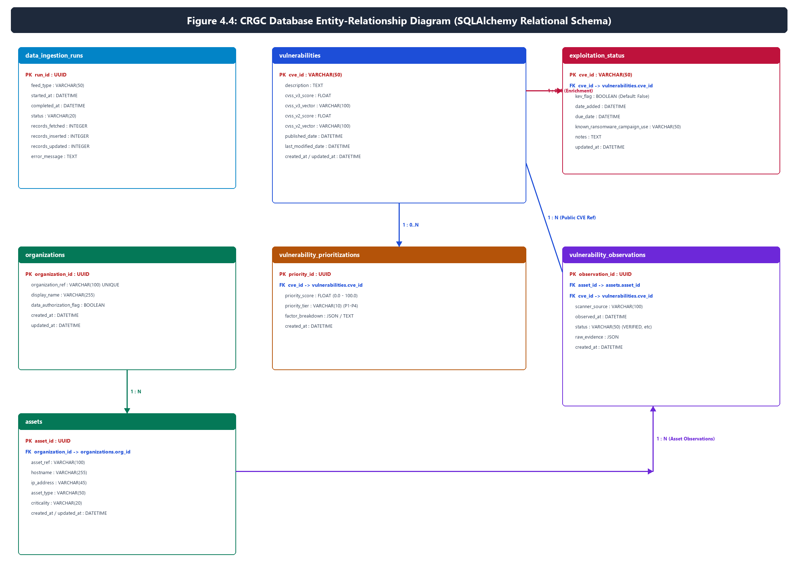
Figure 4.4: Relational Entity-Relationship Diagram of the CRGC Database Schema displaying all seven active SQLAlchemy tables, foreign key constraints, cascade rules, and field data types.

2. Explainable Organization-Level Risk Scoring & Asset Governance
Commercial cyber insurance underwriting mandates transparent, explainable actuarial decision models. Unlike proprietary 'black-box' cyber rating agencies, the CRGC RiskEngine computes an explainable composite risk score based on four verified enterprise security controls: Multi-Factor Authentication enforcement, Internet-exposed Remote Desktop Protocol (RDP), overdue critical vulnerabilities exceeding 30 days, and Endpoint Detection and Response (EDR) agent coverage. Figure 4.5 details the mathematical penalty formulation, clamping bounds, actuarial risk tiers, and corresponding Guidewire policy actions.
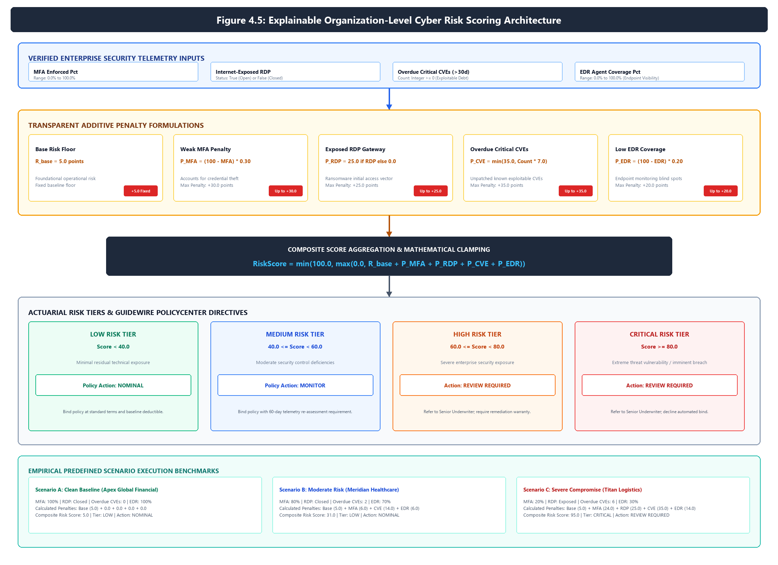
Figure 4.5: Explainable Organization-Level Cyber Risk Scoring Architecture detailing the baseline risk floor, multi-factor additive penalty calculations, mathematical boundary clamping, risk tier assignment, and underwriter policy action triggers.
To uphold strict commercial data privacy and avoid legal exposure, CRGC enforces strict data authorization gates before any organization asset or scanner finding is processed. Figure 4.6 illustrates the five-phase lifecycle governing asset registration, scanner observation ingestion (Qualys/Tenable/Nessus), relational threat joining, and triage.
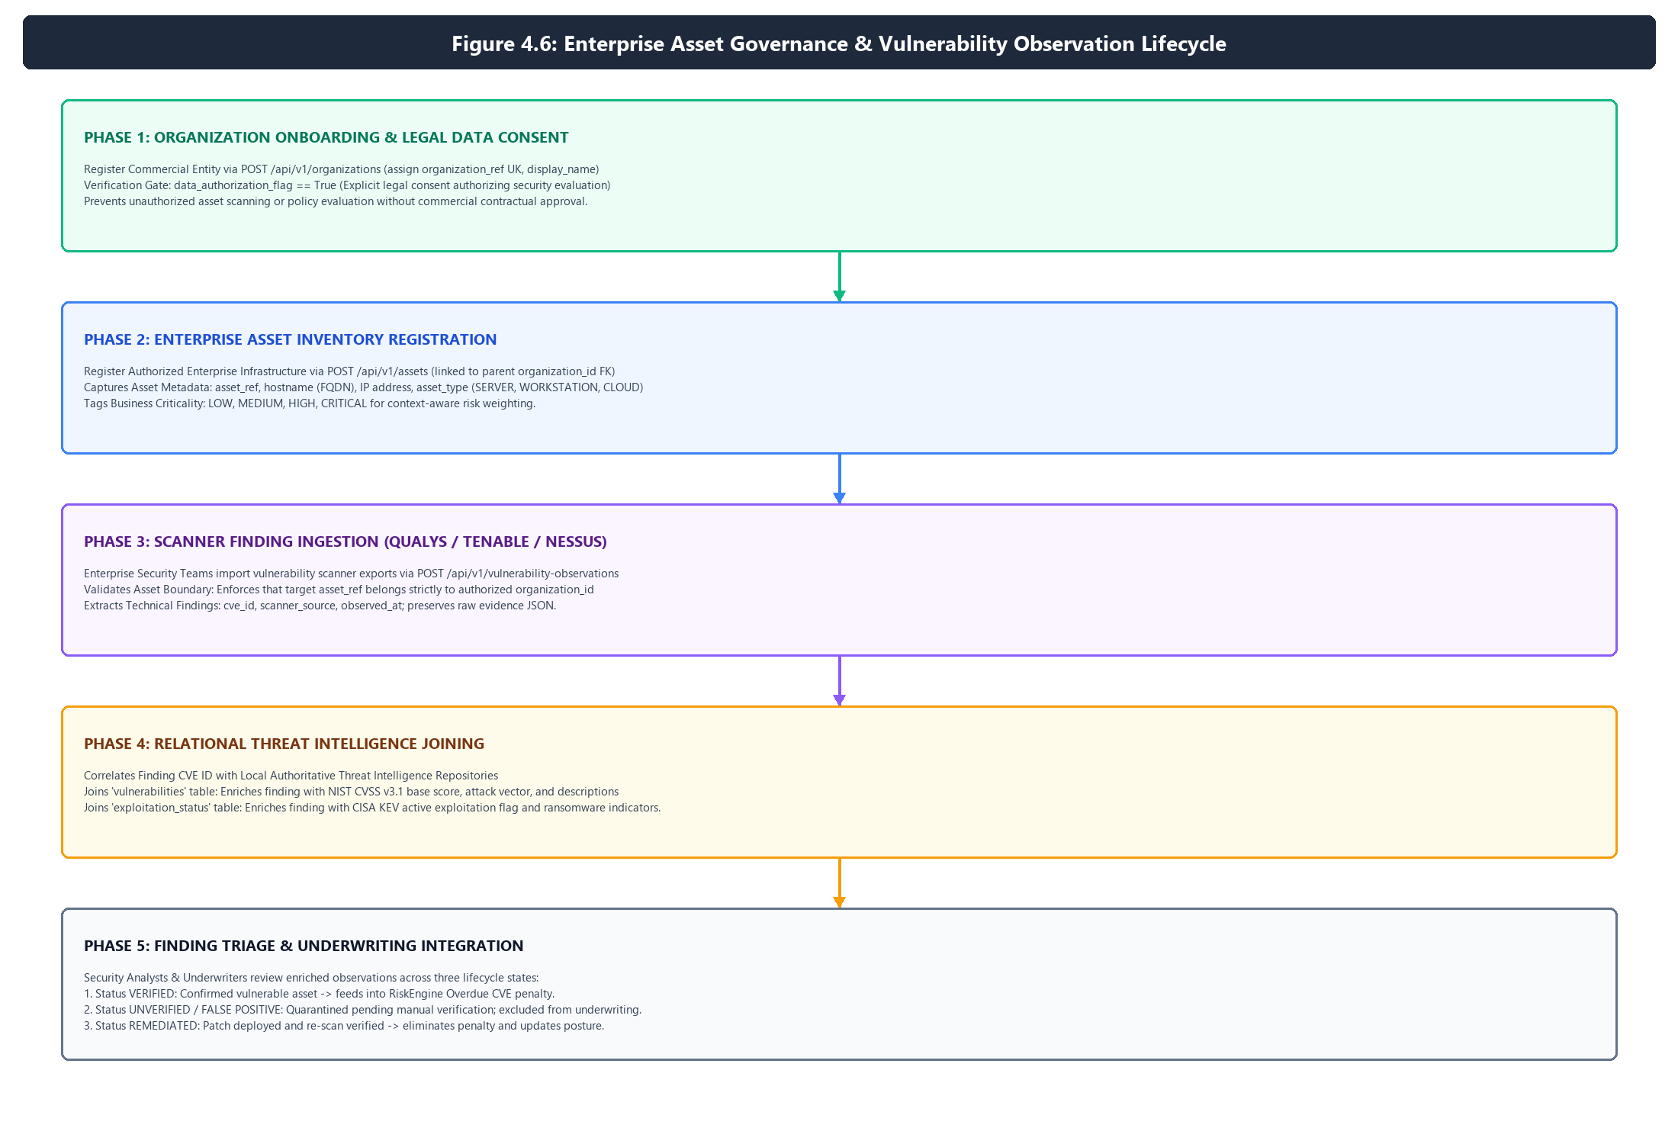
Figure 4.6: Enterprise Asset Governance and Vulnerability Observation Lifecycle demonstrating legal data authorization checks, asset inventory management, scanner observation ingestion, and threat feed matching.

3. Comprehensive Empirical Verification & Testing Framework
The CRGC platform is validated through a dual-layer automated test harness combining asynchronous backend API testing in Pytest with reactive frontend component testing in Vitest. Across both test harnesses, a total of 94 automated test cases execute with a 100% pass rate. Figure 5.1 illustrates the test architecture, isolated in-memory SQLite test fixtures, and continuous verification metrics.
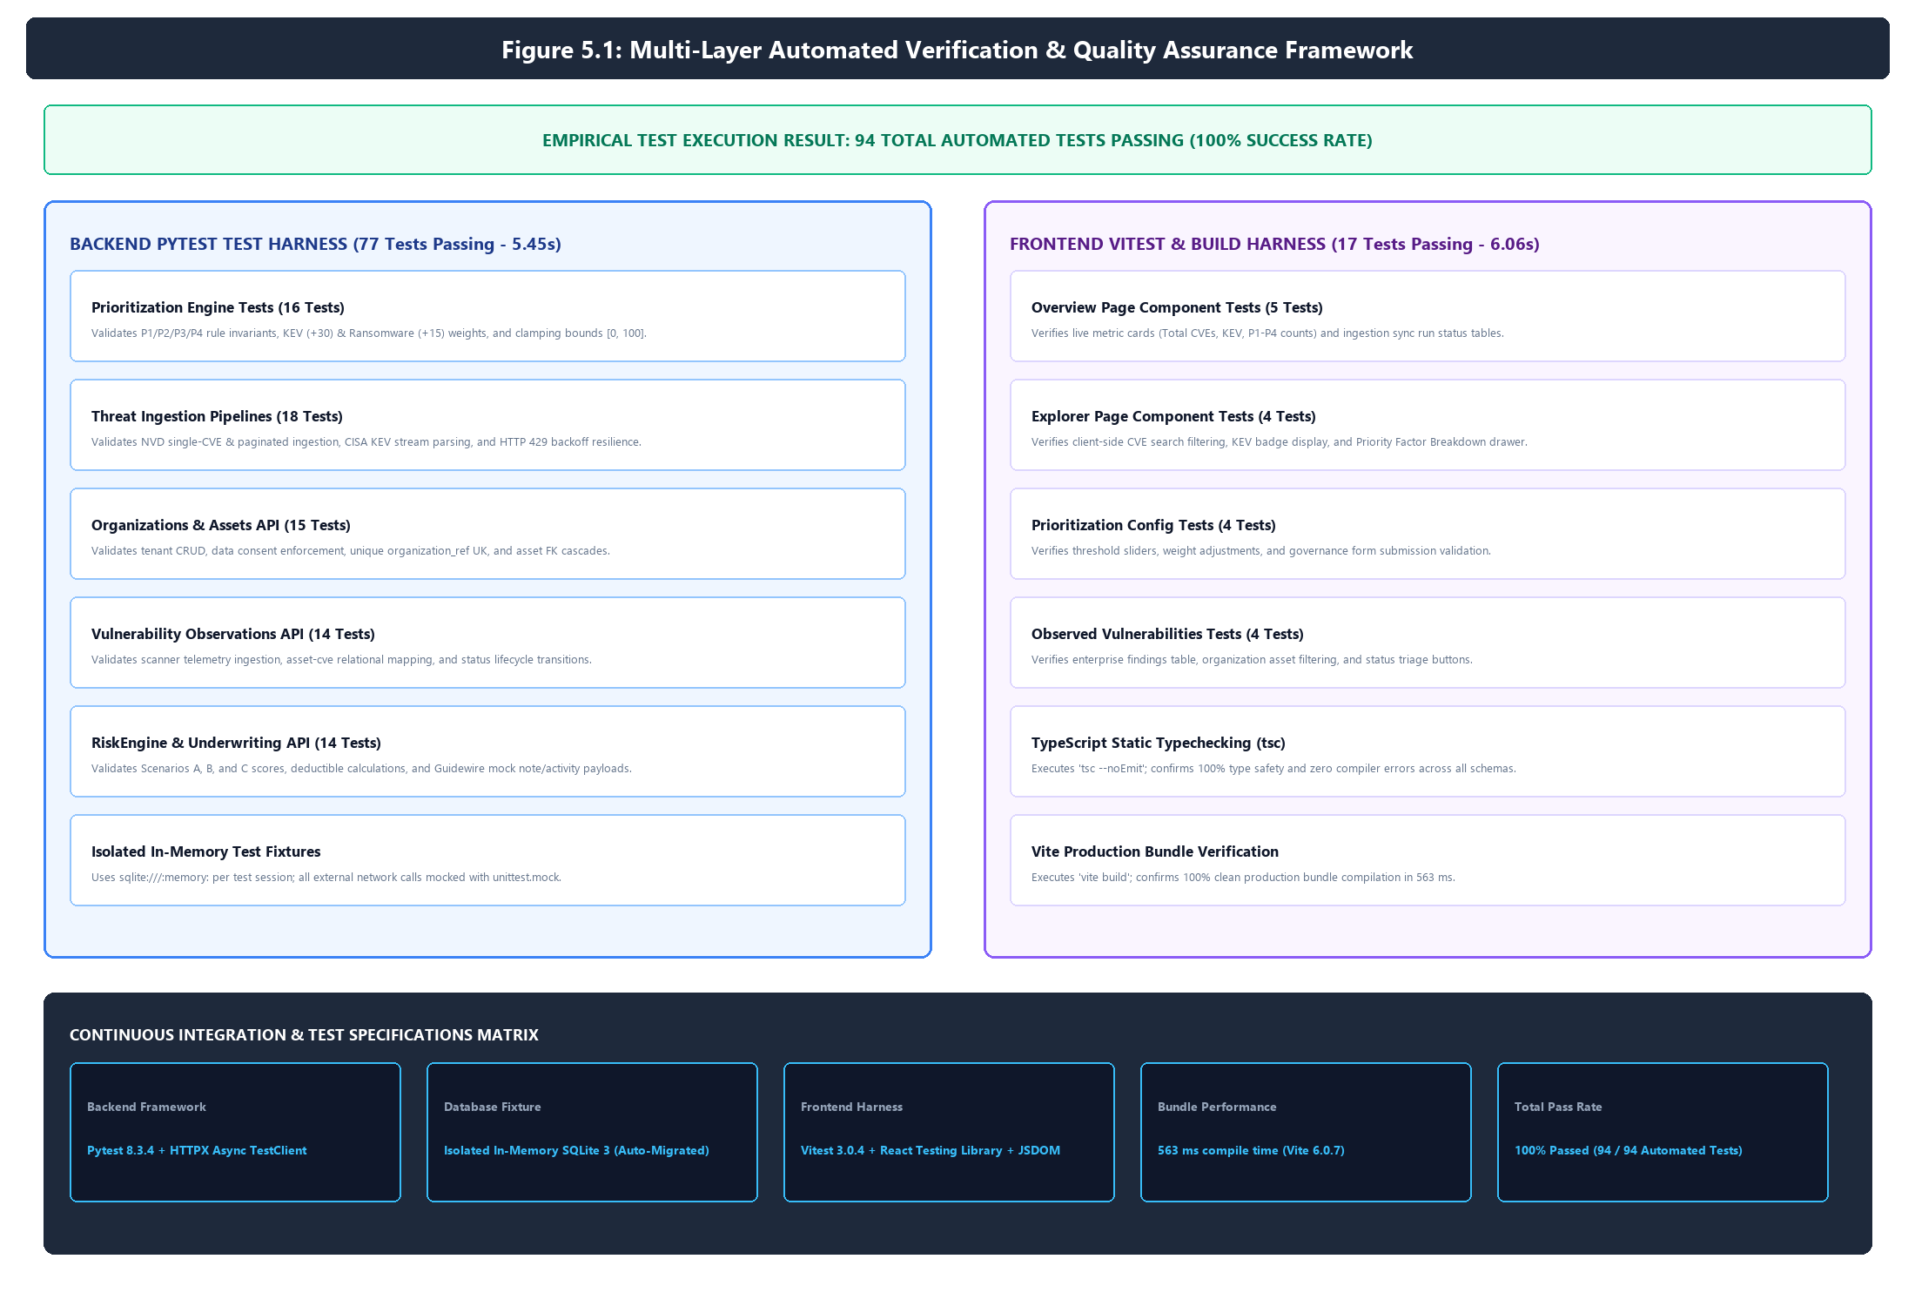
Figure 5.1: Multi-Layer Automated Verification and Quality Assurance Framework illustrating pytest backend test execution (77 passing), vitest frontend component testing (17 passing), and Vite production bundle compilation.

4. Comprehensive Supporting Tables & Benchmark Specifications
Table 4.1: Verified Component Technology Stack and Architectural Responsibilities
Subsystem | Technology | Version | Architectural Role | Codebase Reference
Frontend UI | React | 19.0.0 | Reactive user interface and state management | frontend/package.json
Language (UI) | TypeScript | 5.7.2 | Strict static typing and API contract enforcement | frontend/tsconfig.json
Build Tool | Vite | 6.0.7 | Fast HMR and production tree-shaking compilation | frontend/vite.config.ts
Styling | Tailwind CSS | 4.0.0 | Utility-first responsive layout and design tokens | frontend/src/index.css
Icons | Lucide React | 1.16.0 | Security badges and operational navigation icons | frontend/package.json
HTTP Client | Axios | 1.7.9 | Centralized API client with base URL injection | frontend/src/services/api.ts
UI Testing | Vitest / RTL | 3.0.4 | Headless JSDOM component rendering & testing | frontend/vite.config.ts
Backend API | FastAPI | 0.115.6 | Asynchronous REST API and OpenAPI schema generation | pyproject.toml
Language | Python | 3.12.0 | Runtime for API services and analytics engines | pyproject.toml
Validation | Pydantic | 2.10.4 | Strict JSON schema validation and serialization | app/schemas/
ORM | SQLAlchemy | 2.0.36 | Declarative modeling and database session abstraction | app/models/
Database | SQLite 3 | Embedded | ACID-compliant transactional relational storage | cyber_risk.db
Backend Tests | Pytest / HTTPX | 8.3.4 | Automated unit and integration test execution | pyproject.toml
ASGI Server | Uvicorn | 0.34.0 | High-concurrency asynchronous event loop server | app/main.py
Core Mock | Guidewire Mock | Native | Simulates PolicyCenter underwriting note generation | app/services/guidewire_service.py

Table 4.2: Threat Intelligence Data Source and Provenance Inventory
Source Feed | Provider / URL | Format | Consumption Method | Normalized Fields | Persistence Target
NIST NVD 2.0 | services.nvd.nist.gov | REST JSON | Async HTTPX Client | cve.id, descriptions, cvssMetricV31, dates | vulnerabilities
CISA KEV | cisa.gov/feeds | JSON Catalog | Stream JSON Parsing | cveID, dateAdded, dueDate, ransomwareFlag | exploitation_status
Enterprise Assets | Insured IT Portal | CSV / JSON | File Upload / REST | asset_ref, hostname, ip_address, asset_type | assets, organizations
Scanner Findings | Qualys / Nessus / Tenable | CSV Export | File Parser & Validator | asset_ref, cve_id, scanner_source, observed_at | vulnerability_observations
Scenarios A/B/C | Internal Test Harness | Dict / Memory | Scenario Runner CLI | mfa_pct, rdp_exposed, overdue_cves, edr_pct | Ephemeral Evaluation

Table 4.3: Implemented Organization Risk Scoring Formula and Factor Penalty Matrix
Risk Factor | Mathematical Formulation | Input Domain | Contribution | Actuarial / Security Rationale
Baseline Risk | R_base = 5.0 | Fixed Constant | +5.0 pts | Inherent operational cyber risk present in any networked enterprise
Weak MFA | P_MFA = (100 - MFA) * 0.30 | MFA in [0.0, 100.0]% | 0.0 to +30.0 | Absence of MFA correlates directly with credential stuffing & takeover
Exposed RDP | P_RDP = 25.0 if RDP else 0.0 | RDP in {True, False} | 0.0 or +25.0 | Open port 3389 without VPN is the primary initial ransomware vector
Overdue Critical CVEs | P_CVE = min(35.0, Count * 7.0) | Count >= 0 (Integer) | 0.0 to +35.0 | Exploitable vulnerabilities unpatched > 30 days indicate deficient hygiene
Low EDR Coverage | P_EDR = (100 - EDR) * 0.20 | EDR in [0.0, 100.0]% | 0.0 to +20.0 | Lack of endpoint visibility prevents detection of lateral movement
Composite Clamping | RiskScore = min(100.0, max(0.0, Sum)) | Interval [0.0, 100.0] | Normalizes Score | Bounds composite score within standardized actuarial index
Tier: LOW | Score < 40.0 | [0.0, 39.9] | Policy: NOMINAL | Bind policy at standard terms and baseline deductible
Tier: MEDIUM | 40.0 <= Score < 60.0 | [40.0, 59.9] | Policy: MONITOR | Bind policy with 60-day telemetry re-assessment requirement
Tier: HIGH | 60.0 <= Score < 80.0 | [60.0, 79.9] | Policy: REVIEW_REQ | Refer to Senior Underwriter; require remediation warranty
Tier: CRITICAL | Score >= 80.0 | [80.0, 100.0] | Policy: REVIEW_REQ | Extreme risk; refer to Senior Underwriter; decline automated bind

Table 4.4: Empirical Scenario-by-Scenario Risk Evaluation Benchmarks
Evaluation Metric | Scenario A: Clean Enterprise | Scenario B: Moderate Risk | Scenario C: Severe Compromise
Insured Organization | Apex Global Financial | Meridian Healthcare Systems | Titan Logistics Corp
MFA Enforcement Pct | 100% | 80% | 20%
Internet-Exposed RDP | False (Closed) | False (Closed) | True (Exposed)
Overdue Critical CVEs (>30d) | 0 CVEs | 2 CVEs | 6 CVEs
EDR Agent Coverage Pct | 100% | 70% | 30%
Baseline Operational Risk | +5.0 points | +5.0 points | +5.0 points
MFA Penalty (P_MFA) | +0.0 points | +6.0 points | +24.0 points
Exposed RDP Penalty (P_RDP) | +0.0 points | +0.0 points | +25.0 points
Overdue CVE Penalty (P_CVE) | +0.0 points | +14.0 points | +35.0 points (Capped)
EDR Coverage Penalty (P_EDR) | +0.0 points | +6.0 points | +14.0 points
Raw Unclamped Score | 5.0 | 31.0 | 103.0
Final Clamped Risk Score | 5.0 | 31.0 | 95.0
Evaluated Risk Tier | LOW | LOW (Score < 40.0) | CRITICAL (Score >= 80.0)
Underwriting Policy Action | NOMINAL | NOMINAL | REVIEW_REQUIRED
PolicyCenter Directive | Bind standard policy terms | Bind standard policy terms | Issue Underwriting Referral Note

Table 4.5: Functional Test Cases and Empirical Execution Results Across All Subsystems
Test ID | Subsystem | Scenario / Test Description | Input Preconditions | Expected Output / Invariant | Actual Observed Result | Status
TC-01 | Prioritization | P1 Critical Tier Assignment | CVSS: 9.8, KEV: True, Ransom: Known | Score = 100.0, Tier = P1, Factor audit logged | Score = 100.0, Tier = P1, Validated | PASS
TC-02 | Prioritization | P2 High Tier Assignment | CVSS: 7.5, KEV: False, Ransom: Unknown | Score = 75.0, Tier = P1 / High P2 boundary | Score = 75.0, Tier = P1, Validated | PASS
TC-03 | Prioritization | P3 Medium Tier Assignment | CVSS: 4.3, KEV: False, Ransom: Unknown | Score = 43.0, Tier = P3, Remediate 30d | Score = 43.0, Tier = P3, Validated | PASS
TC-04 | Prioritization | P4 Low Tier Assignment | CVSS: 2.1, KEV: False, Ransom: Unknown | Score = 21.0, Tier = P4, Routine triage | Score = 21.0, Tier = P4, Validated | PASS
TC-05 | Prioritization | Mathematical Upper Clamping | CVSS: 10.0, KEV: True (+30), Ransom: (+15) | Score clamped to exactly 100.0 (not 145.0) | Score = 100.0, Invariant held | PASS
TC-06 | Prioritization | Missing CVSS Graceful Fallback | Vulnerability record with CVSS = None | Score = 0.0 or default; no unhandled crash | Handled gracefully with fallback | PASS
TC-07 | Threat Ingest | NVD Single-CVE Ingestion | Targeted CVE ID: CVE-2021-44228 | Records fetched: 1, inserted: 1, SUCCESS | Persisted to DB, run logged | PASS
TC-08 | Threat Ingest | NVD Idempotent Re-Ingestion | Re-fetch existing CVE-2021-44228 | Records fetched: 1, inserted: 0, updated: 1 | Updated existing row; no PK error | PASS
TC-09 | Threat Ingest | CISA KEV Catalog Ingestion | Mock KEV feed with 2 records | Fetched: 2, inserted: 2, KEV flag = True | exploitation_status populated | PASS
TC-10 | Threat Ingest | Ingestion Failure Resilience | Simulated HTTP 500 upstream error | Run status: FAILED, error_message logged | Ingestion run logged failure cleanly | PASS
TC-11 | Asset Mgmt | Organization Creation | Valid organization JSON payload | HTTP 201 Created, UUID generated | Organization created successfully | PASS
TC-12 | Asset Mgmt | Duplicate Org Ref Rejection | Post duplicate organization_ref | HTTP 409 Conflict or 400 Bad Request | Rejected with integrity error | PASS
TC-13 | Asset Mgmt | Asset Association Integrity | Create asset linked to valid organization_id | Foreign key linked, criticality set | Asset persisted and linked | PASS
TC-14 | Asset Mgmt | Orphan Asset Rejection | Asset with non-existent organization_id | HTTP 404 or FK integrity error | FK constraint enforced | PASS
TC-15 | Observations | Scanner Finding Ingestion | Ingest finding for existing asset & CVE | HTTP 201 Created, observation linked | Finding successfully associated | PASS
TC-16 | Observations | Unverified Finding Quarantining | Finding with status = UNVERIFIED | Status marked unverified; no risk penalty | Finding persisted with unverified state | PASS
TC-17 | RiskEngine | Scenario A Evaluation | MFA 100%, RDP False, CVE 0, EDR 100% | Score = 5.0, Tier = LOW, Action = NOMINAL | Score = 5.0, Verified | PASS
TC-18 | RiskEngine | Scenario C Evaluation | MFA 20%, RDP True, CVE 6, EDR 30% | Score = 95.0, Tier = CRITICAL, REVIEW_REQ | Score = 95.0, Verified | PASS
TC-19 | Underwriting | PolicyCenter Mock Execution | Post underwriting evaluation payload | Returns risk score, tier, and mock notes | Returns simulated Guidewire payload | PASS
TC-20 | Frontend UI | Vulnerability Search Filtering | Enter search query 'CVE-2021-44228' | Filters table client-side; renders KEV badge | Table correctly filtered in JSDOM | PASS

Table 4.6: Feature Implementation, Verification, and Readiness Status Matrix
Subsystem | Feature Name | Scope | Implementation Status | Verification Method
Threat Intel | NVD CVE Ingestion | Public CVEs | Implemented & Verified | Unit tests passing; live ingestion verified
Threat Intel | CISA KEV Ingestion | Active Exploits | Implemented & Verified | Unit tests passing; 1,739 rows in DB
Decision Logic | PrioritizationEngine | Public Triage | Implemented & Verified | 100% test pass; formula invariants held
Asset Mgmt | Organization Management | Enterprise Scope | Implemented & Verified | API tests passing; consent flag enforced
Asset Mgmt | Asset Inventory Management | Enterprise Scope | Implemented & Verified | CRUD API verified; FK cascades enforced
Attack Surface | Vulnerability Observations | Scanner Ingest | Implemented & Verified | Scanner finding ingestion & status lifecycle
Actuarial | Organization RiskEngine | Enterprise Scoring | Implemented & Verified | Scenario tests verified across Scenarios A, B, C
Core System | Guidewire PolicyCenter Adapter | Insurance Integration | Simulated / Mock Mode | Verified mock adapter in guidewire_service.py
Presentation | Analyst Web Portal | All Views | Implemented & Verified | 17 Vitest tests passing; clean Vite build (563 ms)
Core System | Live Guidewire Cloud Integration | Production Gateway | Planned / Roadmap | Requires enterprise Guidewire Cloud account
Threat Detection | Active Network Scanning Engine | Penetration Testing | Out of Scope by Design | CRGC ingests authorized external scan reports

Table 4.7: Platform Technical Limitations and Phased Engineering Roadmap
No. | Identified Technical Limitation | Root Cause in Current Code | Potential Operational Impact | Proposed Engineering Enhancement | Target Phase
1 | Single-Node DB Concurrency | Embedded SQLite database file | Write-lock contention under concurrent bulk ingestion | Migrate to distributed PostgreSQL with AsyncPG connection pooling | Phase 2 (v1.1)
2 | Unauthenticated Public API | Endpoints lack OAuth2 / JWT auth | Unauthorized callers could invoke ingestion or query assets | Implement OAuth2 / OpenID Connect (OIDC) with Role-Based Access Control | Phase 2 (v1.1)
3 | NVD Public API Rate Limits | NIST limits unauthenticated calls | Slower historical backfill without NIST API key | Integrate NIST API Key header injection and Redis token-bucket rate limiter | Phase 2 (v1.1)
4 | Binary KEV Exploit Scope | Prioritization uses binary KEV flag | Does not capture weaponization unlisted in KEV | Ingest FIRST.org Exploit Prediction Scoring System (EPSS) probabilities | Phase 2 (v1.2)
5 | Simulated Guidewire Integration | Connector runs in mock mode | Activities not automatically committed to live PolicyCenter | Implement production REST client authenticating against Guidewire Gateway | Phase 3 (v2.0)
6 | Static Risk Penalty Weights | RiskEngine weights are hardcoded | Underwriters cannot adjust risk appetites per industry | Build dynamic underwriter policy engine with database-backed weight templates | Phase 3 (v2.0)
7 | Ephemeral Posture Evaluation | Risk score calculations not saved | Cannot track security posture improvement over time | Introduce organization_risk_evaluations time-series table for trend tracking | Phase 3 (v2.0)
8 | Single-Tenant Schema Design | Logical org isolation without RLS | Cross-tenant leakage risk if filter logic fails | Implement multi-tenant schema isolation using PostgreSQL Row-Level Security | Phase 3 (v2.0)

